Reducing Chinook Salmon Bycatch with Market-Based Incentives: Individual Tradable Encounter Credits

George Sugihara* and Hao Ye
Scripps Institution of Oceanography
University of California San Diego
and
Keith R. Criddle
School of Fisheries and Ocean Science
University of Alaska Fairbanks

Abstract
The American Fisheries Act of 1998 established permanent sector allocations in the Bering Sea and Aleutian Islands region pollock (Theragra chalcogramma) fishery and allowed the creation of, by contract, individual vessel allocations within each sector. The result was an increase in profitability to the vessel owners and to the fishery as a whole. Recent heightened concern about bycatches of Chinook salmon (Oncorhynchus tshawytscha) in the pollock fishery has led to the imposition, effective 2011, of a hard cap on Chinook salmon bycatch. Under a hard cap, the pollock fishery would close immediately if the Chinook salmon bycatch cap is exceeded. The potentially binding limits on Chinook salmon bycatch threaten to reignite the race-for-fish and dissipate the substantial profits that characterize the current fishery. Moreover, because bycatch rates are crude proxies for Chinook salmon abundance, a simple cap could have the perverse consequence of being most restrictive when Chinook salmon are relatively abundant and least restrictive when Chinook salmon are rare, and in most need of protection. We show that a particular form of individual bycatch quota, the Individual Tradable Encounter Credit (ITEC), can provide an incentive to avoid Chinook salmon bycatch even when the hard cap is not binding, while concurrently minimizing the cost of Chinook salmon avoidance.

Introduction
The Eastern Bering Sea and Aleutian Islands (BSAI) fishery for pollock (Theragra chalcogramma) yields gross exvessel revenues in excess of $300 million and a first wholesale value over $1 billion (Hiatt et al., 2008); it is, arguably, the premier U.S. fishery. BSAI pollock first attracted the attention of foreign distant water fleets in 1960s and early 1970s. The fishery began to be Americanized following passage of what has become known as the Magnuson-Stevens Fishery Conservation and Management Act (MSFCMA) of 1976. Between 1976 and the mid-1980s, the BSAI fishery transformed from a foreign permitted fishery, to a joint-venture fishery composed of domestic catcher boats and foreign motherships. By 1990, the foreign motherships had been replaced by a combination of U.S.-flagged catcher boats that delivered to shore-based processing plants, U.S.-flagged catcher boats that delivered to U.S.-flagged motherships, U.S.-flagged catcher-processors and U.S.-flagged catcher boats that delivered to the catcher-processors. The impetus for this rapid evolution in ownership and organization were the domestic preference provisions included in the MSFCMA, federally-supported vessel construction loan programs, and the first-come-first-serve ownership by capture rules that determined how the total allowable catch (TAC) was to be divvied up.

Because there were no restrictions on the entry of additional U.S.-flagged catcher boats or catcher-processors and no limits on the construction or expansion of shore-based processing facilities, Americanization was not the hoped-for panacea. Indeed, by as early as 1991, harvesting capacity had expanded enough to harvest more than double the BSAI pollock TAC and processing capacity had expanded enough to handle one-and-a-half times the TAC (NPFMC 1991). Special interest groups representing shore-based processors and the vessels that delivered to them and special interest groups representing the catcher-processor sector began to seek conflicting preferential sector allocations from the North Pacific Fishery Management Council (NPFMC). This initial Inshore-Offshore contest led to the creation of fixed allocations: 30.6% to the inshore sector (catcher vessels that delivered to shore-based processors and motherships operating within state waters), 56.9% to the offshore sector (catcher-processors, motherships operating outside state waters but within the EEZ, and catcher vessels that delivered to those catcher-processors and motherships), 7.5% as community development quota (CDQ) to be allocated by the state to entities formed of representatives of qualified western Alaskan communities (Ginter 1995; NRC 1998), and 5% set aside for bycatch of pollock in other fisheries. As harvesting and processing capacity continued to expand, the inshore-offshore battle was reprised in 1995 (NPFMC 1995) and again in 1998 (NPFMC 1998)—where the inshore sector was awarded ever increasing shares of the TAC. Congress intervened in 1998 and set permanent allocations in the American Fisheries Act (AFA) of 1998: 43.6% to catcher vessels that delivered to shore-based plants, 8.5% to catcher vessels that deliver to motherships, 31.9% to catcher-processors, 3% to catcher vessels that delivered to catcher-processors, 10% to CDQ entities, and a 2.8% set aside for bycatch of pollock in other fisheries. In addition, the AFA placed a moratorium on the entry of new vessels, set parameters for the formation of cooperatives within sectors, and provided funds to buy out nine of the twenty-nine then active catcher-processors (AFA 1998). All sectors quickly organized under intercooperative agreements, civil contracts, that created sub-sector allocations to each firm. Sub-sector allocations share many of the characteristics of individual fishing quotas (IFQs): they represent an assured opportunity to harvest a known fraction of the TAC and they can be sold or leased within their sector. Since implementation of the intercooperative agreements, the catcher boat and catcher processor fleets have consolidated and become more economically efficient, utilization rates (pounds of finished product per pound of fish caught) have increased, production has shifted towards higher-value product forms, and economic returns have increased (Criddle and Macinko 2000; Anderson 2002; Felthoven 2002; and NPFMC 2002).

The pollock fishery uses mid-water trawls to target schools of pollock. This fishery has very low bycatch rates (e.g., 1.1% by weight in 2006 and 1.2% by weight in 2007) and even lower discard rates (e.g., 0.28% in 2006 and 0.30% in 2007) (Hiatt et al. 2008). Nevertheless, the magnitudes of pollock catches are so large that even minor bycatch rates represent substantial levels of bycatch mortality. In 2007, for example, bycatch mortality included 264 mt of halibut (Hippoglossus stenolepis), 338 mt of herring (Clupea pallasi), 3.8 thousand crabs (Paralithodes sp., Chionoecetes sp., and Lithodes sp.), 109.1 thousand Chinook salmon (Oncorhynchus tshawytscha), and 83.3 thousand other salmon (O. sp.) (Hiatt et al., 2008).

Figure 1 depicts the recent history of Chinook salmon bycatch in the BSAI pollock fishery during the A-season (January, February, March) and B-season (June, July, August, September).
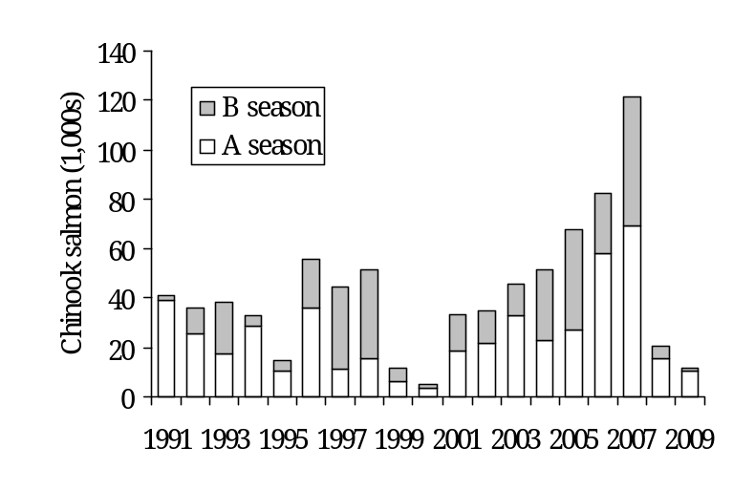
Figure 1. Chinook salmon bycatch in the BSAI pollock mid-water trawl fishery, 1991-2009.

Past efforts to reduce Chinook salmon bycatch relied on combinations of fixed and dynamic spatial closures (NMFS 1995, NMFS 1999, NPFMC 2005). Failure of these measures to avert the large bycatches observed in 2005, 2006, and 2007 provided the impetus for adoption of an annual hard cap on Chinook salmon bycatch mortality (NPFMC 2008). In addition to being highly variable between seasons and across years, Chinook salmon bycatch varies between regions, and between hauls by like vessels fishing in like areas at like times. The causes of this variability are unknown as is the relationship between Chinook salmon bycatch and subsequent returns of mature salmon to the drainages in which they were spawned. Based on the results of genetic stock identification of Chinook salmon taken as bycatch, and on the age-distribution of bycaught Chinook salmon, NPFMC (2008), suggests that bycatch in the pollock fishery reduced the number of Chinook salmon available to target fisheries and to escapement by 78,344. Of this total, it was estimated that 56.6% (44,380) would have returned to coastal streams in western Alaska, 12.4% (9,743) would have returned to coastal streams along the northern Alaska Peninsula, 1.7% (1,302) would have returned to the middle and upper Yukon drainage, 26.5% (20,745) would have returned to the Gulf of Alaska, Southeast Alaska, or Pacific Northwest.

The Preliminary Preferred Alternative (PPA) selected by the NPFMC in April 2009 and submitted for approval by the Secretary of Commerce specifies a framework under which one of two binding caps would apply and specifies how those caps will be apportioned among the sectors and conditions under which they could be apportioned within sectors. NPFMC recommendations are advisory to the Secretary of Commerce who approves or disapproves the proposed changes to established Fishery Management Plans (FMPs). Based on the anticipated time needed for NOAA Fisheries to prepare regulatory language to implement the NPFMC's recommendation, as well as the amount of time legally required for public comment and response to public comments, it is anticipated that the cap would become effective in January 2011.

Under the PPA, 40% of the bycatch cap is to be apportioned to the A season and 60% to the B season. During the A-season, catcher-processors will be allocated 32.9% of the A-season cap, motherships will be allocated 8%, shore-based catcher boats will be allocated 49.8%, and CDQ entities will be allocated 9.3%. During the B-season, catcher-processors will be allocated 17.9%, motherships will be allocated 7.3%, shore-based catcher boats will be allocated 69.3% and CDQ entities will be allocated 5.5%. Although these sector allocations are primarily (75%) based on sector bycatch history (2002-2006), they also reflect pollock allocations under the AFA; in effect, sectors with “dirty” fishing history received a somewhat smaller bycatch allocation than their proportionate share of historical bycatch. The PPA provides fishery participants with an opportunity to choose between a simple hard cap of 47,561 Chinook salmon (approximately 34,153 adult equivalents) and a less restrictive cap of 60,000 Chinook salmon (approximately 43,086 adult equivalents) accompanied by the adoption of an intercooperative agreement (ICA) that creates individual-level incentives to avoid bycatch even when the cap is non-binding. The ICA alternative also stipulates that the average annual bycatch be less than 47,561 in at least 4 of every 7 years and includes a provision under which vessels that opt out of the ICA face an open access bycatch pool equivalent to their share of an overall hard cap of 28,496 Chinook salmon. Unused A-season bycatch allowances can roll into the B-season cap. For sectors or groups of vessels within a sector to operate under the ICA alternative, they must prepare a NOAA-Fisheries approved ICA that demonstrates the following attributes: 1) it rewards individual vessels that successfully avoid Chinook salmon or penalizes individual vessels that fail to avoid Chinook salmon; 2) it creates incentives to avoid Chinook salmon bycatch at all levels of abundance in all years; and, 3) it creates incentives that will influence fishing decisions even when bycatch is at levels below the hard cap. These requirements were established because d

espite popular appeal, managing fishery bycatch with restrictive hard caps can produce unintended negative outcomes (such as the race for turtle bycatch seen in the Hawaiian swordfish fleet in 2006). This is particularly true when the prohibited species catch exhibits wide variation in numbers from year to year as with Chinook salmon bycatch in the Bearing Sea pollock fishery. In this case, the fundamental weakness of a restrictive hard cap is that it protects Chinook salmon populations exactly when high encounter rates suggest that they are abundant and in least need of protection and offers no protection when low encounter rates suggest that Chinook salmon populations are low and vulnerable to overexploitation. Simple hard caps and plans based on fixed performance standards (e.g., a bycatch target of 47,561 with a fixed hard cap of 60,000) are most punitive when Chinook salmon least need protection and offer no penalty when salmon are infrequent; they create a mismatch between penalties and infractions.

In this paper, we present a market based bycatch credits-trading plan—the Industry Market Incentive Plan (MIP)—using individual (vessel-level) tradable encounter credits (ITEC), that addresses the incentive requirements of the ICA alternative. This approach provides robust vessel-level incentives to reduce Chinook salmon bycatch under all levels of pollock biomass and at any rate of Chinook salmon bycatch and can act cumulatively through time though consistent competition to further reduce overall fleet Chinook salmon encounter rates. The plan is flexible, and with experimental implementation and monitoring can be tuned to meet predetermined performance standards.

Model
Sectors are assumed to receive annual allocations of salmon encounter (bycatch) credits (1 ITEC = 1 Chinook) in amounts as described under the PPA. Within each sector, the ITEC would be distributed to individual vessels under intercooperative agreements—civil contracts—enacted within co-ops according to a specifically designed uniform allocation rule (the Legacy Allocation Rule) that provides vessel-level incentives to avoid Chinook salmon encounters and explicitly addresses each of the ICA alternative's required performance attributes. It is assumed that vessels can use or trade ITEC within and across sectors to offset salmon bycatch encounters and these transfers of ITEC are moderated by rules (e.g., Dynamic Salmon Savings) that further reinforce ICA performance attributes and prevent potential abuses.

The MIP rewards vessels with low (relative to other vessels) Chinook salmon bycatch levels, by: providing them with bonus ITEC in subsequent years and by creating a market for the sale of surplus ITEC to vessels that lack enough ITEC to harvest the balance of their pollock allocation. Conversely, the MIP penalizes vessels with high Chinook salmon bycatch levels by: decreasing their initial allocation of ITEC in subsequent years and through forcing vessels that have exhausted their current year ITEC to buy ITEC, to lease the balance of their pollock allocation to vessels with surplus ITEC, or to forego harvesting the balance of their pollock allocation.

The main objective of the MIP is to create cumulative financial incentives for a fleet-wide reduction of salmon bycatch in a way that provides vessel-level incentives to reduce Chinook salmon bycatch in order to minimize the expected value of the opportunity cost of foregone pollock harvests. That is, it minimizes industry losses due to unharvested pollock under a hard cap while encouraging continual competitive evolution toward diminishing overall Chinook salmon bycatch.

The MIP includes a Legacy Allocation component (rules to reallocate ITEC among vessels to address long-term financial incentives) and a Transfer component (rules to regulate ITEC trading between vessels to address both long- and short-term financial incentives).

The Legacy Allocation component reallocates ITEC away from vessels with high encounter rates toward cleaner fishing vessels. It creates long-term “insurance-like” incentives against catastrophic revenue losses that could occur under the PPA hard cap at times of moderate to high Chinook salmon encounter levels. A particular strength of the Legacy Allocation scheme is that the incentives to avoid bycatch are strongest in years of low salmon abundance, when Chinook salmon populations may be at greatest risk. At these are times, the value of ITEC measured in tons of pollock per Chinook salmon are highest while the value of ITEC under a simple hard cap would be negligible because the hard cap would not be binding. Legacy-based reallocation depends on the past record of performance to determine current allocations (akin to a grade point average). This cumulative record creates inter-annual accountability, and dampens the effect of occasional chance events (bad luck) that are not due to individual vessel behavior. It emphasizes the behavioral component of vessel bycatch rates and minimizes the effect of chance encounters. Legacy Allocation creates a cumulative incentive for individual vessels (and hence, the fleet) to adopt consistent behaviors to reduce overall bycatch and its associated costs.

The Transfer component of the MIP discourages chronic bad players who place a drag on the fleet, reinforces vessel-scale incentives, and keeps the realized bycatch far below the hard cap whenever possible (i.e. through Dynamic Salmon Savings). The Transfer component limits the number of credits that a vessel can purchase and significantly reduces the excess supply of credits especially during low abundance years. It reinforces the long-term incentives of the allocation scheme as well as the short-term incentives created by trading ITEC by promoting higher credits prices in times of low encounter rates.

Auxiliary features of the MIP include
an industry sponsored research component to monitor and evaluate program efficacy at reducing bycatch as well as to obtain basic information on Chinook salmon population dynamics (e.g., run strength and stock assessments) to better understand the impacts of Chinook salmon bycatch on the viability of Chinook salmon populations and aligned fisheries. The MIP would
implement a fixed fishing closure area (currently referred to as the Chinook Conservation Area). In addition, the MIP includes
a 2-strikes rule to weed out chronic offenders and a 3% emergency fund saved as a tax by the ICA entities to safeguard against genuine bad luck encounters

Auxiliary benefits of the MIP include
the establishment of an independent (certified) organized market place for conducting fishery business. This infrastructural cornerstone would likely find support from outside sources. It would represent a significant step forward toward market efficiency and transparency and would be scalable to other bycatch issues and the trading of financial instruments to control risk. In addition
, along with transparency this system will provide natural price signals for the value of bycatch, in terms of the risk and costs of forgone Pollock when ITEC become limiting. A major strength of this system is that the penalties and rewards are tied naturally to the actual market value of bycatch to the Pollock industry.

Introduction:

Regional pollution credits trading schemes have been shown to provide effective financial incentives to allow industries over time to evolve new behaviors to minimize emissions, and do so with minimal financial stress. A hallmark example is the New England sulfide emissions market, created in 1990 to regulate atmospheric SO₂ released by coal-burning power plants. Regulators set caps on individual plant emissions and allowed plants to trade offsets to keep below the cap. Non-polluters are rewarded by collecting revenues from sales of credits while emitters are penalized by buying credits to offset their sulfide emissions. This market-based system provides individual firm incentives for the industry to dramatically reduce sulfide emissions. It is estimated that in the first decade the emissions trading system resulted in SO₂ reductions, totaling a 40% reduction nationally from 1980 levels (a 10 million ton reduction annually), the largest and most successful program of its kind designed to date. This market-based incentive system has shown the potential to save up to half of the compliance costs associated with more traditional source-by-source emission limit programs (Rico 1995). In general open market-incentive systems can be relatively inexpensive to implement and enforce, in part because as a many player game, they are not easily manipulated.

Here we will examine a new market-incentive system to reduce Chinook salmon bycatch that is analogous to the sulfide offsets trading scheme, but only in its use of credits trading to create short-term individual vessel incentives to reduce Chinook encounter rates. More significant individual incentives of this MIP come from an annual allocation scheme for ITEC that creates long-term accountability for current behavior or “insurance-like” incentives to reduce bycatch. These allocation incentives promote responsible behavior, are cumulative, and as required under the ICA alternative of the PPA, they operate at all levels of salmon encounter. Most significantly, the incentives for bycatch avoidance created are strongest at low levels of salmon encounter: times when Chinook populations may be most vulnerable.

In effect, avoiding bycatch in low encounter years enhances a vessel’s subsequent ITEC allocations and creates “insurance” for moderate-to-high-encounter years when credits may otherwise be unavailable; times when many vessels would otherwise deplete their encounter credits before they can fully harvest their pollock quota. With this allocation scheme, the financial benefits of having additional encounter credits can be considerable. Similarly, the costs of having a reduced ITEC allocation can be high.

One of the more interesting things we find is that even without any incentives operating in the historical data, the ITEC reallocation scheme alone actually results in lower bycatch and higher industry revenues (Figure 6). This occurs because vessels already show some consistency in bycatch behavior (in the historical non-incentivized data), and the allocation scheme tends to move credits away from poor performing vessels toward cleaner vessels. Not surprisingly, more dramatic cumulative benefits accrue when the incentives are explicitly acknowledged (Figure 9). Moreover, the magnitudes of these incentives and of the consequent bycatch reduction can be adjusted with monitoring and experimentation to fit most reasonable standards. Because of the complexities of human behavior, we believe that the magnitudes of bycatch reduction in any plan cannot be determined ex ante, but will require monitoring and evaluation. An advantage (and political liability) of this plan is its flexibility with regard to parameterization to accommodate adjustments if necessary.

This analysis will focus on the inshore catcher-vessel sector using annual data on pollock harvests and Chinook salmon encounters from 2003-2007, and in part from daily data from 2000-2007. These data show that without behavioral changes, vessels will run out of credits under the simple PPA hard cap even in low abundance years (Figure 2). If ITEC are expensive or unavailable for sale, the cost of unfished pollock due to a shortage of credits can be considerabl). Therefore, in thenMIP the best position for a vessel owner to be in is to have sufficient ITEC in reserve to never have to buy credits, and have the option of gaining extra revenue by selling unused credits. These aims can be accomplished with bycatch avoidance.

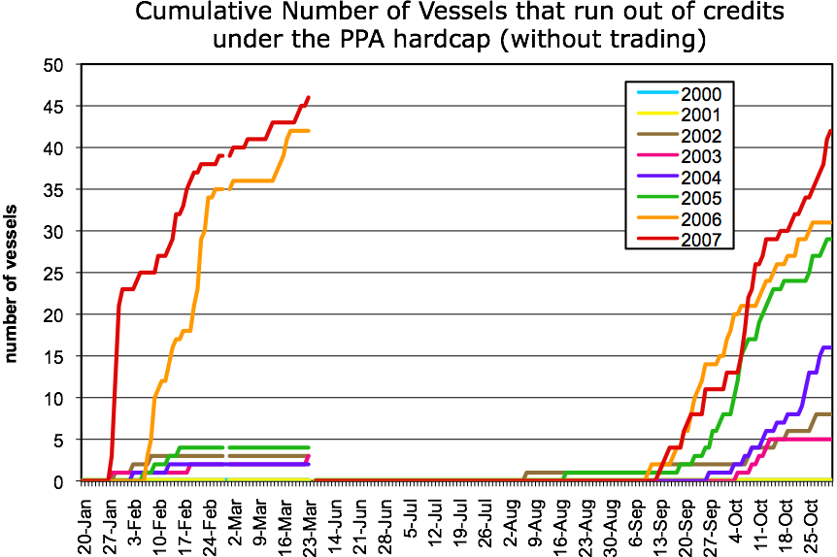
Figure 2. Timing and cumulative numbers of vessels in each season that would have run out of encounter credits under the PPA hard cap with no trading and without changes from fishing practices engaged before the introduction of a hard cap. (from Inshore sector daily data). Note that some vessels would have run out of credits even in low encounter years (e.g. 2002, 2003).

This is clearly only an indication as it is hard to predict how people would behave with a hard cap in place. The 2006 experience with Hawaiian Swordfish and turtles produced a race for bycatch. Still the graph is instructive as it gives an indication of what might happen in the neutral case, “with all things being equal.”

Model Specification: Basic Elements of the Plan

Initial Sector Allocation:
Sectors are given fixed annual allocations of salmon encounter (bycatch) credits (1 ITEC = 1 Chinook salmon) in amounts as described in the ICA alternative of the PPA under the industry-wide hard cap of 60,000. For this analysis, the inshore catcher-vessel sector receives 36,900 credits, of which 11,952 are reserved for the A-season and 24,948 credits are reserved until the start of the B-season.

Legacy Vessel Allocation: (a key element)
Individual vessel allocations of ITEC are made separately for each season (A and B-season computed separately) and it is assumed that 100% of any remaining A-season credits are carried forward to the B-season. A 100% carry-forward rule creates incentive to avoid bycatch in the A-season and keeps ITEC prices high at the end of A-season because of the uncertainty in bycatch levels that will occur in the B season. As is evident in Figure 1, B-season Chinook salmon bycatch can be substantial, particularly late in the B-season (NPFMC 2008). The carryover builds additional incentive for careful fishing (conservation of ITEC) in the A-season, by providing additional insurance for completing the B-season pollock harvest. As we discuss below, careful fishing in the B-season is incentivized mainly by the Legacy Allocation scheme as well as by the rewards and penalties associated with trading ITEC.

A key provision of the MIP is a formula to reward vessels with low Chinook salmon encounter rates by reallocating extra encounter credits the following year, and conversely penalize vessels with high encounter rates. This creates several different incentives to lower bycatch, including having extra credits as insurance against costly moderate to high salmon abundance years (times when additional ITEC are likely to be needed to finish one’s pollock allocation and times when little ITEC will be available for purchase because other operators will have similarly large bycatch rates). The cost of unfished pollock due to a shortage of credits can be considerable. The allocation scheme uses these potential costs as incentive for individual vessels to maintain a maximal reserve of credits.

Under the MIP, at the start of each season, credits are distributed to the individual vessels through their membership in a cooperative and according to an allocation formula that takes three factors into account for that vessel:

- Pollock quota for the season
- Previous year’s proportional allocation factor for the season (season specific legacy)
- Previous year’s relative bycatch rate for the season (season specific bycatch)

This is summarized in the following general formula:
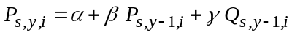 (1)
where 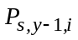 is the proportional allocation factor for vessel i for season s (i.e., A-season or B-season) of year y. The constants α, β and γ are proportional weights that sum to unity (see Appendix A for a more detailed derivation). For simplicity, the analyses based on annual data shown here use yearly averages (dropping i), and the results have the same qualitative behavior as those based on daily/seasonal data. The first term α serves as a fixed constant, the second term β is the weight given to the previous year’s proportional allocation factor (the “legacy” term), and γ is the weight given to the bycatch function 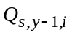, which can assume any sensible monotonic form that penalizes high bycatch rates. A particularly nice property of (equation 1) is that (for most parameterizations) it is possible to derive asymptotic upper and lower limits for P that place bounds on how far the proportional allocations for any vessel can ultimately deviate from their initial allocation.

The proportional allocation factor reflects a vessel’s allocation relative to its initial allocation. During the first year of implementation, all vessels within a cooperative governed by an ICA would receive an ITEC allocation pro rata to their pollock allocations and the proportional allocation factor for each vessel would be unity. In subsequent years, this proportional allocation factor will fluctuate (between some asymptotic bounds) and vessels will receive differing ITEC allocations. For vessels with the same pollock allocation, the relative values of their proportional allocation factors will reflect their relative ITEC allocations: if one vessel’s proportional allocation factor is 20% larger than the other vessel, it will receive 20% more credits than the other vessel (again, assuming that the vessels receive the same pollock allocation).

The formula in equation (1) is presented in a generic and flexible form to emphasize the fact that with monitoring and feedback on performance, the parameters can be tuned to effect different magnitudes of bycatch reduction and performance standards. We note, however that the actual magnitude of bycatch reduction produced by any plan involving complex human behavior cannot be known ex ante, except by experimental implementation. We will return to this issue in the section on “Hypothetical Modeling of Incentives,” where we present a heuristic simulation and crude estimate based on what can realistically be known without experimental manipulation.

Specific Parameterization Used Here:
Here we will consider the specific case where the bycatch function is linear of the form 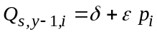 where δ and ε are constants and p_{i} is the penalty value for vessel i computed via a penalty function dependent upon the relative bycatch rate of vessel i. (See Appendix A for a detailed description of calculations). In addition, for heuristics two different weighting schemes will be considered that alter the importance of the legacy component: when 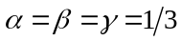 (equal weighting) and 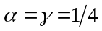 and 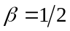 (augmented legacy weighting), and where 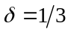 and 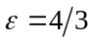. That is, we will consider
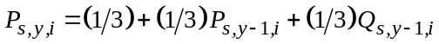 (2)
or the (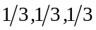) “equal” weighting. And,
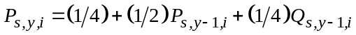 (3)
or the (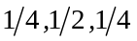) “augmented legacy” weighting.

Both of these weighting schemes have a lower bound of 2/3 relative to the initial allocation (based on pollock) and an upper bound of 4/3. This means that in both formulas (2) and (3) no vessel can lose more than 1/3 of its initial allocation or gain more than 1/3 as insurance against running out of credits in moderate to high salmon abundance years. A swing of 2/3’s in the allocation scheme is reckoned to provide sufficient motivation for the incentives to be effective, however this can be adjusted as necessary (See Appendix A for a discussion of bounds and weighting formulas). These specific bounds [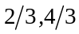] are the lower and upper bounds recommended to industry, along with augmented legacy weighting.

Most of the analyses here are based on the augmented legacy model (equation 3). Except for the speed of convergence (speed at which it is possible to recover from a low ranking) the results here do not differ qualitatively from equation (2) (see Appendix A-5 for a discussion of convergence). Indeed, equation (3) may be preferable in some cases as discussed below. In particular, a higher weight given to the legacy component is a way to minimize the random effects of sampling error in bycatch rates (bad luck encounters) and emphasize the consistent intentional behavioral component of variation in ITEC allocations among vessels. Because the year-to-year changes are smaller, vessels must do consistently well (i.e., lower bycatch) in order to obtain the maximum possible increase in ITEC allocation. Similarly, vessels which initially have high bycatch are given more opportunities to improve over time. That is, a larger β in equation (1) helps to sort out the behavioral component from the chance component in determining relative seasonal ITEC allocations (penalties and rewards). However, the smaller value for γ creates less yearly incentive to reduce bycatch, as the changes in proportional allocation factor will be smaller. One must balance these two factors in arriving at a final model. As a starting point we suggest the augmented legacy weighting [], and unless otherwise stated, this weighting will be used in our analysis.

Again, it is assumed that these allocation factors are computed separately for each season and that there is100% carry forward of remainder credits from the A-season to the B-season. In practice, a running tab will be kept to let each vessel know in real-time where it stands with respect to the “expectation” of next year's relative allocation. This way there are no surprises, and people will be informed and better motivated. Each vessel can know where it stands “on the fly” relative to the sector (presumably only the data on fleet-wide bycatch will be available to each vessel, with individual vessel performance remaining private information). It is worth noting that privacy is not essential here. In contrast to UIP/FIP there is no advantage to knowing the rank of others, thus the advantage that larger companies might posses in those systems is moot in the Legacy Plan.

The incentives created by the asymptotic behavior of the Legacy Allocation model provide continual incentive to reduce bycatch and promote consistent good behavior. Thus, if a vessel is near the top of the pack, then it will remain near the top of the pack only if it consistently continues to perform well relative to the fleet. If a vessel at the top of the pack has an average year (middle of the pack), it will loose some credits in the subsequent reallocation. It is not possible for vessels to slack off and maintain an augmented ITEC allocation. Incentives are always present (from year 1 onwards). This also means that there is consistent vessel-level incentive for improvement—because credits are transferred from vessels with high bycatch rates to cleaner vessels, the bycatch rates for the fleet as a whole continuously ameliorate.

Conversely, if a vessel is at the bottom of the heap in terms of bycatch avoidance, it will remain there only if it stays at the bottom relative to other vessels in each year. It can dig out of this hole by consistently moving its behavior closer to the mean. The constant competition and a cumulative record of how competitive you are will stimulate a steady decline in the industry average bycatch rate.

Because of the large variability in Chinook salmon abundance, even vessels at the asymptotic lower limit of ITEC allocation may not be forced to forego pollock harvest every year. However, this should not be viewed as a flaw in the legacy plan. These vessels will likely lose a large amount of potential revenue in mid- and high-encounter years. During these times, trading of credits will be scarce, so these vessels will be unable to simply purchase more credits to continue fishing pollock. The only reasonable options for these vessels (to avoid revenue losses) are to improve their allocation by reducing their bycatch rates or to sell there pollock history (AFA allocation) and associated ITEC to a cleaner vessel. Due to the nature of the plan, this can be accomplished even with small changes in bycatch rates: such a vessel would not need to reduce bycatch dramatically to see improvements in ITEC allocation (but larger reductions in bycatch would result in larger increases in ITEC allocation). Thus, these vessels are incentivized to reduce bycatch in all years, even when their allocations may not be binding.

Another option to deal with the worst offenders is to consider some sort of special rule (see Appendix D-2), which might prohibit vessels that are the worst offenders in consecutive years from purchasing any credits. These rules may provide additional incentives for vessels that may be initially unresponsive to the incentives laid out in the legacy plan.

A “False Legacy” Model:
To further clarify how Legacy allocation works it is interesting to consider a degenerate case of the general Legacy Allocation formula, equation 1, occurs when 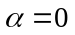 and 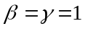, which no longer has the desired legacy behavior:
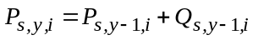 (4)
Here the relative legacy-term weight is adjusted via the bycatch function, Q, which will have a different form than discussed above. Equation (4) describes a simple random walk where the proportional allocation factor P_{y} , depends only on the last value P_{y-1} , and the bycatch term, Q, which is simply a random variable. Unfortunately, this simple random walk formula for credits allocations no longer has the desirable property of asymptotic bounds, and it can increase or decrease indefinitely (and even go negative). However one can implement an ad-hoc patch to this problem by setting arbitrary limits on P (e.g., hard limits of [] as effective absorbing bounds to the random walk).

The cost associated with the lack of convergence to natural limits is that equation (4) is not really a legacy system in terms of the way incentives work, nor in terms of separating out the behavioral component from the chance component. It lacks all of the interesting strengths that make a true Legacy system work.

For example, if you are at the top of the heap, you will remain there if you have an average year. There is no incentive to improve beyond achieving the average. Similarly, if you are at the bottom of the heap, you will stay there, even if your bycatch rate is average (middle of the pack) the next year. Thus the realistic strategy for “dirty” vessels is to stay “dirty”. In other words, once you become an A student you remain an A student even if you perform like a C student from then on, and once an F student, you remain there even if you consistently perform like a C student. A consistent C student can get rewarded in perpetuity as an A student or and F student. There is a discontinuous mismatch between current actions and consequences—it is a degenerate case that will produce a distribution of allocations that is flat with spikes at either end.

Asymptotic (gradual) convergence to intrinsic upper and lower bounds (e.g., ) is essential to have sensible incentives (e.g., consistent good behavior etc).

Although equation (4) lacks the sensible cumulative incentive dynamics associated with equations (2) or (3), it is not without merit. Namely, it is easy to explain and adjust in ad-hoc ways, and is therefore likely to be useful in non-technically guided discussions about specific parameter implementations. For example, it is possible to specify a rapid linear (non-asymptotic) approach to a boundary. Thus, the limits on Q could be set so that a lower-bound can be hit in three years, giving rise to a “3-strikes rule” so that the consistent worst case performer hits the lower limit (e.g., 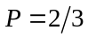) in 3 years starting from the initial allocation. Here, the penalty for being the worst performing vessel is equal for all 3 years (e.g., 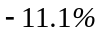) rather than in progressively smaller increments (see Figures A-5 and A-6) as the vessel approaches the lower-bound in the more general case (e.g., equation 2). Yet as seen in the Appendix (section A, Figures A-5 and A-6), the differences in convergence behavior between this alternative and the true Legacy alternatives can be small; so although it is not a viable incentive system, it may be useful in sharpening discussion.

Scaling for Vessel Size to Place Small Independent Vessels on a level Playing Ground with Large Vessels and Firms
The variance in bycatch rates between vessels can be attributed, in part, to chance encounters with patchy dense pockets of Chinook salmon, which is related in part to sample size effects or sampling variation. This, in turn, is directly related to vessel size. Consequently, as shown in Figure 3 and Appendix A-4, the variance in bycatch rates of smaller vessels in the inshore sector is systematically higher than that for larger vessels. That is, small vessels suffer greater risk of completing a season with an overall bycatch rate that is inflated by the occurrence of an unusually “dirty” tow—larger vessels or companies with multiple vessels can average such unusual hauls over a large number of total hauls and thereby diminish the influence of unusual observations on the overall seasonal bycatch tally. Because small vessels are subject to more sampling error of this kind (Figure 3), we used a corrected standard deviation in the allocation calculation to adjust for the effects of random noise due to vessel size (Appendix A-4), effectively treating vessels belonging to a single company as a single large vessel. This random noise varies with the inverse square root of 1 + pollock allocation % and is applied to put small independent vessels on the same level playing ground with respect to legacy allocations as larger vessels and companies that employ many vessels (see Appendix A-4 for details). It is a minor but measureable correction on reallocation that removes the disadvantage of increased risk experienced by smaller vessels.

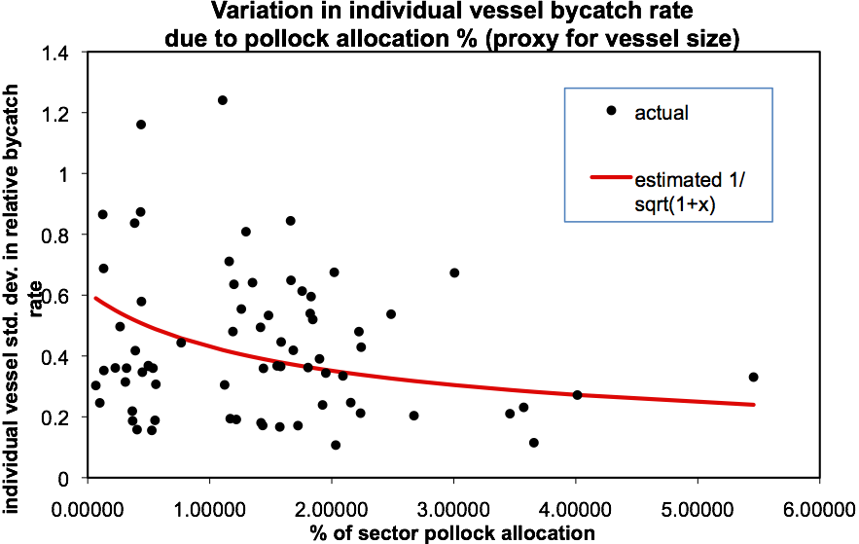
Figure 3. Smaller vessels show higher variability in bycatch rates. (annual data)

Scaling to Avoid Penalizing Competitive Improvement Through Time
In addition to various forms of sampling variation, the variance in bycatch rates between vessels can also be attributed in part to consistent behaviors shown by vessels that appear to directly influence bycatch rates (caution in gear deployment, choices of fishing location, tow speed, timing, etc.).

One reasonable expectation of the MIP is that the variance in the distribution of bycatch rates among vessels will decrease over time as vessels adopt bycatch reducing operational strategies. As this happens, bycatch rates will fall and an ever increasing proportion of the variation in bycatch rates will be due to random chance rather than operational choices of skippers. Indeed, as shown in Figure 4 for all of the sectors combined, there is a clear tendency for lower variance in bycatch rate to accompany a lower sector bycatch rate, reinforcing the idea of a narrower distribution of rates accompanying lowered rates. This suggests rescaling variances to keep a level playing field (see Appendix A-4 for details).

This scaled variance, is intended as a simple correction for the fact that with time the variance in bycatch rates should decline, meaning that the effects of equivalent random variation on subsequent allocations will grow. Basically, this rule keeps incentives from increasing artificially as the variance in bycatch distributions falls through time. That is, as the distribution of bycatch rates within a sector becomes narrower, vessels will need to effect smaller changes in bycatch rates to see the same change in ITEC allocation. This scaling was implemented in the MIP to ensure that variance in relative bycatch rate continues to reflect behavioral differences rather than noise even as the fleet converges to lower bycatch rates. Industry is concerned with vessels getting punished or rewarded due to chance encounters when the distribution of bycatch rates for the fleet become narrow. Rather than thinking of this as “diluting” incentives, it is better to think of this as preventing the potential artificial amplification of incentives due to systematic declines in variance. We do not want to penalize vessels because the fleet is getting better.

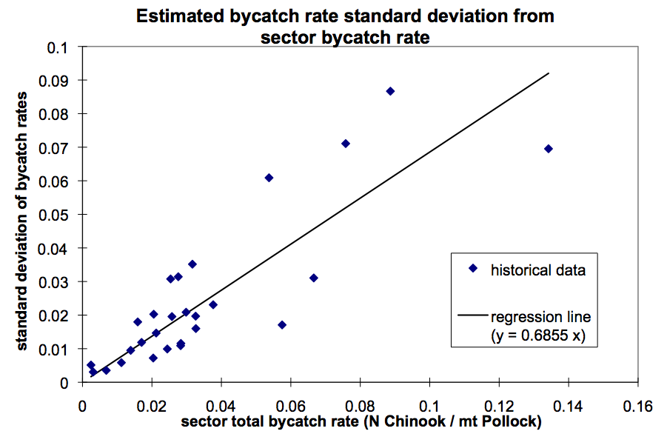

Figure 4. Standard deviation of bycatch rates as a function of sector total bycatch rate. (Annual data from multiple sectors. Provided by Sea State). Narrower distributions of bycatch among vessels accompany lower sector bycatch rates, meaning equivalent actions a lower bycatch levels produce larger effects in ITEC allocation (higher incentives at lower bycatch levels).

As we shall discuss below, this figure shows that allocation incentives are stronger during periods of low encounters, in that as the distribution of bycatch rates within a sector becomes narrower with lower bycatch rates, vessels will need to effect smaller changes in bycatch rates to see the same change in ITEC allocation

Legacy Incentives with this parameterization
Given the specific bounds [], the magnitude of the financial incentives created by Legacy Allocations can be large in terms of the value of pollock quota left unharvested when vessels run out of ITEC and credits are not readily available for sale.

A vessel that fishes cleaner can realize more value per Chinook salmon bycaught. Likewise a less skillful vessel with high encounter rates realizes less value. Thus, ITEC has a higher intrinsic value to a cleaner vessel than to one with high encounter rates. In the short term, clean vessels will be net seller’s of ITEC or net buyers of pollock catch shares and will perceive a higher value, while vessels with high bycatch rates will be net buyer’s of ITEC or sellers of pollock catch shares. The allocation scheme steadily puts more ITEC in the hands of cleaner vessels so that overall fleet bycatch will decline with time.

Transfer Rules

ITEC Supply and Pricing Considerations:
The price of encounter credits will be determined by market perceptions of supply and demand and these in turn will be driven mainly by the perceived risk of running out of ITEC or of needing one’s full complement of ITEC to finish the season.

Because this uncertainty is greatest at the beginning of the season, the price of ITEC is likely to be highest at that time. ITEC will generally be unavailable for sale early in the season. Indeed, vessels are more likely to offer ITEC for sale only after completing their pollock harvest, when the cost of running out of credits is no longer at risk.

As individual vessel owners become willing sellers of surplus ITEC once their pollock quota is harvested, the supply of ITEC will increase which will put downward pressure on ITEC prices toward the end of the season. During times of moderate to high Chinook salmon encounters, this rising supply will be met with rising demand and prices could actually increase toward the end of the season. However, during times of low encounters this could result in a glut of ITEC at the end of the season. The potential for an end-of-season glut could cause a drop in ITEC prices, and a reduction in short-term incentives, paving the way for abuse (i.e. diminished incentives to reduce bycatch). Thus, transfer rules are required to regulate the demand for and supply of ITEC.

We examine two types of transfer rules for ITEC:

“Buy side” transfer rules and
“Sell side” transfer rules (fixed tax on transfers vs. dynamic salmon savings).

We recommend that the best outcome is likely to come from using both kinds of transfer rules together to support incentives for Chinook salmon bycatch avoidance, especially during times of low salmon encounters.

Buy Side Transfer Limits:

So that a poorly performing vessel (one at the 2/3 allocation level) can never obtain more than its original allocation through purchase we recommend the following buy side transfer limit: “in each season only an amount less than 1/3 of a vessel’s credits allocation for that season may be purchased.” This means that the worst performers (with lower allocations) will be able to buy fewer credits, while the better performers, with larger initial allocations, are further rewarded with the ability to potentially buy more if needed. This fixed buy-side transfer limit is simple to implement and should not affect the profitability of the sector but is likely to encourage the transfer of pollock catch shares to “clean” boats.

The benefits of this simple rule are that:

- It addresses individual vessel incentives (a requirement of the ICA alternative in the PPA).
- It addresses the possible abuse of abundant encounter credits during low salmon abundance years (a requirement of the ICA alternative in the PPA: influences decisions at levels well below the hard cap).
- It will not affect the completion of pollock harvest (as shown in historical simulations)
- It reinforces the incentives provided by the legacy allocation system because vessel ITEC allocations (P) and buy side limits move in tandem. (a requirement of the ICA alternative in the PPA: reward vessels that avoid bycatch and penalize those that do not).
- Insofar as it depends on the allocation proportion, P, the buy-side limit is more vulnerable to readjustment during times of low salmon abundance, placing more incentive there. (a requirement of the ICA alternative in the PPA: create incentives at all levels of abundance in all years).
- It provides additional incentives for the worst performing vessels to reduce bycatch, in order to increase their proportional allocation factor and enable the purchases of additional credits. (a requirement of the ICA alternative in the PPA)

Again, a buy side transfer limit means that the worst performers (those with lower allocations) can buy fewer credits. Thus, it resonates with the legacy system, and it augments incentive for salmon avoidance during periods of low encounters.

Sell Side Transfer Limits: (Dynamic Salmon Savings)

Fixed Transfer Tax:
A fixed sell-side transfer tax is not desirable to industry as it can potentially limit the pollock harvest. Neither is it desirable to Chinook salmon conservation as it is dependent upon transfers taking place. During years of low salmon encounter, very few transfers will take place, reducing the effectiveness of a fixed transfer tax exactly when it is most needed. Conversely, transfers of ITEC occur more frequently and in greater volume during years of moderate to high salmon encounter; at these times, a fixed transfer tax will increase the burden of an already limited ITEC supply. Such times are when credits are most needed by the pollock industry. Fixed transfer taxes are not a good fit to this problem.

Dynamic Salmon Savings (DSS):
Thus, we suggest a Dynamic Salmon Savings rule that is adaptive to salmon encounters and will apply to each vessel after it completes its pollock harvest. This is more complicated to implement, but more desirable to Chinook salmon interests than a buy side rule alone or a fixed tax, as it represents a true salmon savings rule (i.e., a salmon exclusion rule) that creates much more protection for Chinook salmon during times of low encounters.

The Dynamic Salmon Savings rule imposes a constraint on the “sell” side of transfers. It includes a sector specific “salmon savings rate” (SSR) that is applied to each vessel’s surplus ITEC. Remainder credits = a vessel’s credits left after filling its B-season quota + credits sold prior to filling quota + A-season carry-forward. The sector specific SSR calculated near the end of the B-season should have the following characteristics:

- Address the possible abuse of abundant encounter credits during low salmon abundance years.
- Will not adversely affect the completion of pollock harvest.
- And is a function of Chinook salmon abundance.

The idea is to set the sector SSR at some reasonable time before the end of B-season, and do this as a function of how much of the sector pollock TAC has been caught. There is a trade-off between how accurately the SSR can be calculated and how soon in the season the fraction can be determined. This tends to happen later in the B-season during low salmon abundance years and earlier in moderate to high abundance years. This enforces more conservation in low abundance years and encourages higher ITEC prices.

The simple dynamic salmon savings rule consists of two parts:

- A provisional savings rule that applies to vessels that sell credits before they finish fishing in the B-season. The provisional savings rule requires that ITEC savings must be held in reserve to meet the maximum SSR. This promotes salmon savings early in the year.

- Determination of a valid SSR far enough in advance of the end of the season to be useful. SSR is the fraction of residual ITEC that must be retired when a vessel completes its fishing. Surplus ITEC are credits that a vessel did not use to fish its full quota of pollock.

Prior to setting the seasonal SSR rate, transfers would be allowed, but only up to some fixed percentage of their residual ITEC, the ITEC left after filling their B-season quota less the ITEC sold prior to filling their pollock quota. Residual ITEC includes carry-forward from the A-season. The provisional salmon savings rule (PSSR) would require that vessels selling ITEC early must have a reserve of credits set aside to accommodate the largest possible SSR. This covers the fact the remainder credits include credits sold. It acts as a withholding tax for credits sales.

For example, if a cap is set so that the maximum SSR is 60% (a number that historically will not limit the harvest), then prior to setting the dynamic savings rule (e.g., throughout the A-season), boats that have finished fishing early can only sell up to 40% of their residual ITEC. The PSSR = 60%, or the maximum SSR. Thus, if a vessel wishes to sell 40 credits early in the year, it must keep 60 ITEC in reserve until the SSR is calculated. This PSSR reserve acts as a de facto conservative salmon savings rule governing transfers until the SSR is posted. It operates like “tax withholding” and protects (holds ITEC in reserve) a large fraction of salmon until the SSR is posted.

A provisional savings rule prevents potential abuses that may occur if vessels sell ITEC before they “finish” fishing. Since ITEC would not be retired until a vessel “completes” fishing, a vessel could sell all of its credits before fishing its complete pollock allocation as a strategy to avoid having ITEC retired. A provisional savings rule prevents this exploitation by requiring that the appropriate ratio of credits be set in reserve for each transfer that occurs before a vessel finishes fishing or before the SSR is set (as in the preceding example).

Numerical experiments with the Inshore sector daily data over an 8-year period suggest that calculating the SSR when 2/3 of the B-season sector pollock quota are caught (2/3 sector TAC) gives the best result, in terms of estimating the credits needed to complete the season (see Appendix B for details on calculating the SSR). This is the “estimated total sector by-catch for the B-season.” This estimate normally occurs between August 29 and Sept 16 (Appendix B). This tends to happen later in low salmon abundance years (when fewer transfers are needed) and occurs earlier in moderate to high abundance years (see Table B - ).

A dynamic salmon savings rule should increase the effectiveness of a market-incentive plan with regards to protecting Chinook salmon and meeting the PPA ICA alternative requirements. One of the primary criticisms of the 60,000 hard cap on Chinook salmon bycatch is that it is set too high. This level of hard cap poses the problem of satisfying the requirement of incentivizing reduced salmon bycatch at all levels of abundance. A lower hard cap, is one possible solution. However, historical data show that salmon encounter rates vary over a wide range. A low hard cap can pose significant financial risk for the pollock fishery during years of high salmon encounter (indeed, historic performance suggests that a 60,000 hard cap would have created financial risk for some vessels even during years of moderate salmon abundance: Figure 2). Conversely, a high hard cap would result in excess ITEC (and the potential for abuse) during years of low salmon encounter. The ideal solution to this problem would be to develop sophisticated methods for accurately forecasting salmon abundances and encounter rates. A much more feasible alternative is an adaptive rule, such as Dynamic Salmon Savings (DSS), which is adjusted each year, taking into account that season’s observed level of salmon encounterr. Unlike a Fixed Transfer Tax, DSS retires ITEC during times when surplus ITEC ie abundant and the potential for abuse is high. A fixed tax can only retire credits when transactions occur. During low-encounter years, few transactions take place (because most vessels have enough credits to fish their own pollock allocation). Thus, a fixed tax will fail to be effective during times of low salmon encounter, precisely when a transfer rule should be most effective.

In our simulations of the number of credits retired under a fixed transfer tax scheme and DSS, we found that DSS retired significantly (over 4 times) more credits over a span of 8 years (2000 - 2007) for the Inshore catcher-vessel sector (using daily data, see 4a). Not only does DSS save more credits than a fixed transfer tax over this 8-year period, but the savings occur during years of low salmon encounter under a DSS scheme (Figure 4b). Details regarding the implementation of both the fixed transfer tax and dynamic salmon savings can be found in Appendix B, along with more detailed simulation results.

One potential issue related to DSS is the estimation of the number of ITEC needed to complete harvests of pollock. Because this is an estimate of the amount of bycatch that the industry might experience for the rest of the season, it has the potential to influence fishing behavior. We believe that it will not adversely affect bycatch rates (i.e., elevating bycatch rates above what they would be without such an estimate). Like all estimates of bycatch, it is subject to error: the large fluctuations in bycatch levels and salmon abundances from year-to-year and season-to-season should make individual vessels cautious about running out of ITEC. Furthermore, although some vessels may become less careful in avoiding bycatch if the estimate of bycatch is too high, they can be taken advantage of by vessels that are rigorous in avoiding bycatch. Since vessels are competing with each other for increased allocations, vessels that have lower bycatch relative to other vessels will see increased allocations. The competitive aspect of the legacy plan means that an estimate of bycatch will adversely affect bycatch rates only if all vessels are lax about reducing bycatch. Seeing even one vessel outperform the rest will incite the rest of the fleet to catch up.

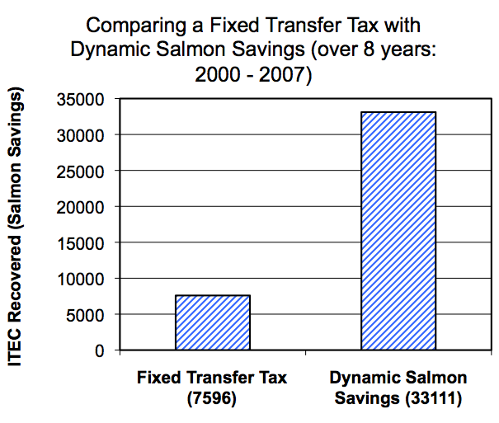
Figure 5a. Number of retired credits over 8 years (2000 – 2007) under two different sell-side transfer rules: a fixed transfer tax and dynamic salmon savings.

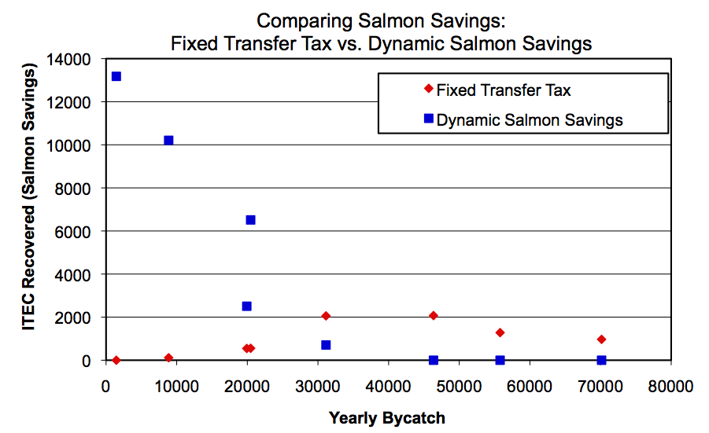
Figure 5b. Number of ITEC recovered vs. yearly bycatch (proxy for salmon abundance) for two different sell-side transfer rules. More ITEC is saved during low salmon abundance years using Dynamic Salmon Savings.

Incentives/Issues

Industry costs associated with non-transferability of credits.
Without a transfer mechanism, some individual vessels will run out of ITEC, and pollock could go unfished, resulting in significant revenue losses for the pollock industry and losses of net benefits to the nation. These losses could happen even during low to moderate Chinook salmon encounter years. Figure w illustrates the timing of how many vessels run out of credits in each season under the proposed Inshore sector hard cap of936,900 assuming no behavioral change in response to a hard cap (includes 100% A to B carry forward). Note that this zero-th order indication shows the result

What is interesting here is that in 2000 and 2001 apparently no vessels would have run out of ITEC (hence no trading would be required). However, in other low Chinook salmon encounter years, 2002, 2003 and in the moderate Chinook salmon abundance years 2004, 2005, an increasing number of vessels would have run out of Chinook salmon encounter credits. This suggests that while no trading was required in 2000 and 2001, that it would have been required in other years.

The sector revenue loss associated with not being able to trade encounter credits under a hard cap scenario can be considerable. These costs are illustrated in Figure 6, and can exceed $62m in a single year. The risk of catastrophic losses due to unharvested pollock in any given year should provide strong financial motivation for industry to adopt a plan for transferring ITEC, in addition to incentivizing individual vessels to lower bycatch rates so that they may be rewarded additional ITEC allocations. Moreover, vessels that may run out of ITEC, even in moderate encounter years, will be incentivized to lower their bycatch rates to make maximal use of their ITEC allocation and to secure a sufficiently high ITEC allocation in subsequent years.

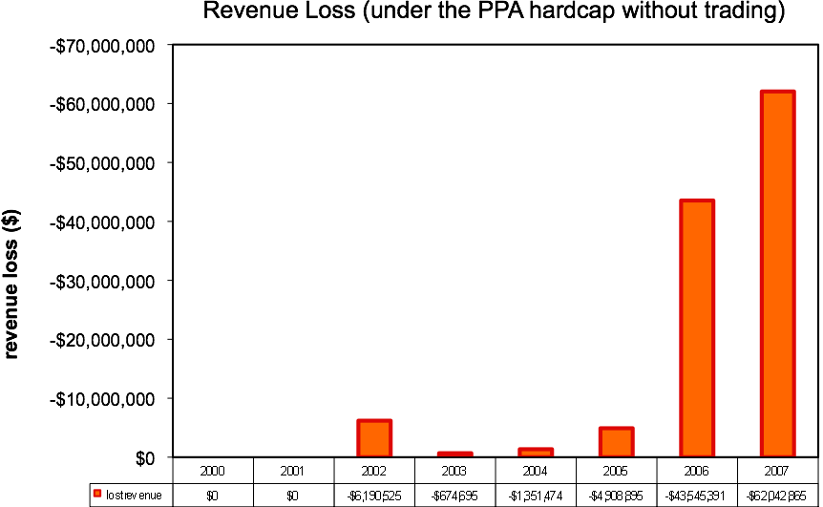
Figure 6. Annual sector revenue losses that would have been incurred under the maximum hard cap (as specified in the PPA) if no reallocation, no trading, and no bycatch avoidance incentives were in place. This calculation is based on daily catch data from Sea State Inc. and the assumption that the A-season price for pollock is $0.20/lb and the B-season price is $0.12/lb.

Trading encounter credits even without explicit incentives to avoid bycatch can increase industry revenues and reduce fleet bycatch. Figure (7) illustrates a hypothetical scenario where reallocation (using equation 2) and trading occurs by the following simple rules:
- ITEC are only traded after a vessel has finished its pollock quota for the season.
- ITEC are transferred as soon as they are needed and are made available to the vessel(s) that have run out of ITEC and for whom the intrinsic value (non-market value) is highest, thus will be most likely to want to buy them.

The remarkable thing here (see Figure 7) is that this shows that there can be significant revenue advantages to credits trading for the sector as a whole, despite the fact that there is no explicit individual motivation to avoid bycatch. Although the effect is modest, the natural dynamics of the allocation scheme and the trading model by itself can enhance revenues, and reduce bycatch for the fleet as a whole.
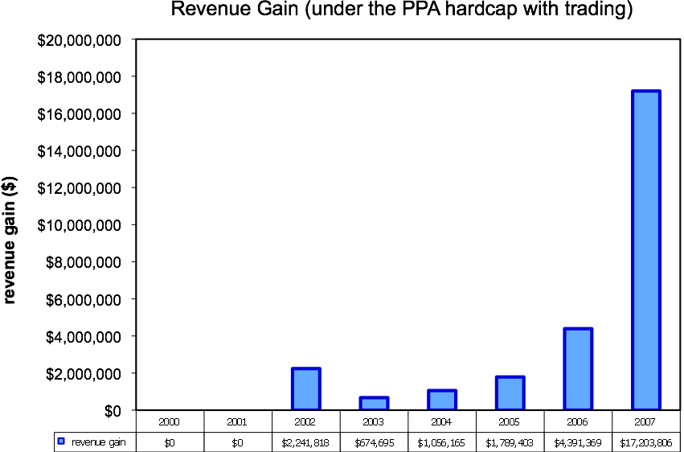
Figure 7. Potential revenue recovered from trading Chinook salmon encounter credits (ITEC’s) under the PPA hard cap. Even without explicit incentives to avoid bycatch, Legacy Reallocation by itself can help to maximize industry revenues. Reallocation assumed “equal weighting” with 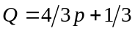 and a linear penalty function.

Note that no trading is projected to have been necessary in 2000 or 2001, as all vessels would have made it through the season without running out of credits.

Infrastructure for Monitoring and Trading ITEC
Perhaps the greatest long term benefit of the ITEC trading and allocation plan is the establishment of an independent (certified) organized market place for conducting fishery business. This infrastructural cornerstone would be likely find support from outside sources and could be an independent CFTC certified contractor such as the Chicago Climate Exchange. Having such certification would bring credibility and would represent a significant step forward toward market efficiency and transparency and would be scalable to other bycatch issues and the trading of financial instruments to control risk.

Handling Transfers Across Sectors
As originally conceived, the MIP would operate throughout an entire sector. However, this is not required. What is required is that trading of ITEC across sectors or subsectors operating under different bycatch incentive programs would be restricted; sectors with Dynamic Salmon Savings can sell credits to any other sector, but may only buy credits from another sector with a Dynamic Salmon Savings rule and the same maximum Salmon Savings Rate.

From the point of view of maintaining rational incentives in the MIP the following rules should apply to transfers across groups or sectors that may or may not participate in the plan:
- Unless otherwise regulated, sectors with Dynamic Salmon Savings (DSS) may sell credits to any other sector.
- Unless otherwise regulated, sectors without DSS may buy credits from any other sector.
- A sector with DSS cannot buy credits from a sector without DSS.

Incentives and Issues related to the allocation scheme.
A key incentive mechanism for the tradable encounter credits model is the allocation of credits based on current and past (legacy) encounter rate behavior. As we have already seen (Appendix B) the intrinsic fishery value of ITEC can be very high, and in years of high salmon abundance, the cost of forgone pollock under a Chinook salmon hard cap can represent a catastrophic loss. The possibility of having surplus ITEC increases the value of avoiding current bycatch out of concern that future there are years could involve moderate to high Chinook salmon abundance. This requires forward thinking similar to buying insurance. Having extra credits reduces the risk of foregone pollock catches or the need to purchase ITEC in years of moderate to high Chinook salmon abundance.
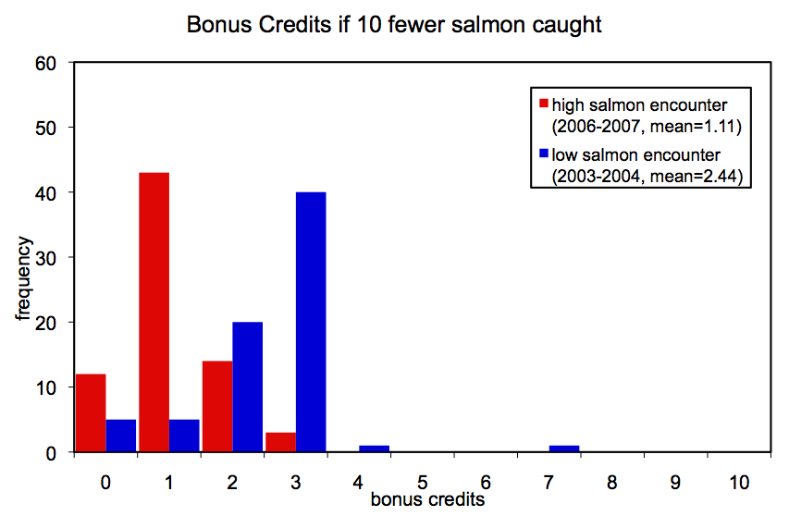
Figure8a. Surplus ITEC achievable with 10 fewer Chinook salmon caught using the “equal weight” Legacy Allocation Formula (equation 2) with a linear penalty function. This is analyzed vessel by vessel (based on original annual data).

The additional revenue per bonus credit in the 2007 A-season (assuming the vessel would have otherwise run out of credits) is on the order of $7k to $20k/ITEC—a strong motivation in terms of oportunity cost.

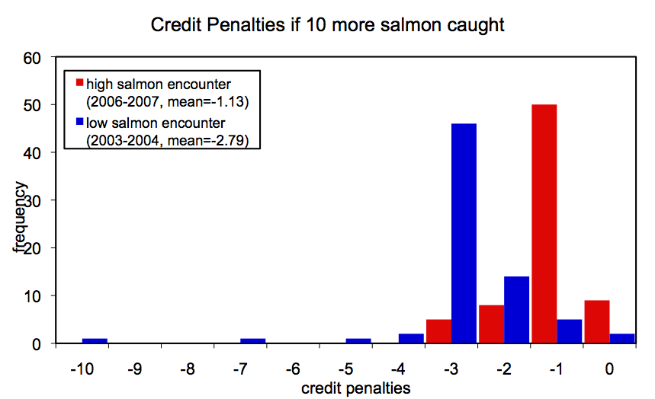
Figure 8b. Credit penalties (reduced ITEC) as a result of 10 more Chinook salmon caught using the “equal weight” Legacy Allocation Formula (equation 2) with a linear penalty function (based on annual data).

Of special significance is the fact that this allocation scheme operates more sensitively during years of low salmon abundance (Figure 4 and 8a,b). That is, vessels are more strongly rewarded or penalized for fishing behavior during low salmon encounter years. Additionally, the intrinsic fishery value of the credits is higher at times of low salmon abundance (Appendix B).

Incentives related to trading ITEC.
In general, if vessel-owners expect to have surplus ITEC in any given year, they can post it for sale on an electronic market site. This could represent significant extra revenue, especially if there is significant asymmetry in performance among vessels. Alternatively, they could enter into the market to lease or but additional pollock catch shares from vessels that are at risk of running short of ITEC needed to complete their pollock harvests. Similarly, if a vessel owner needs to buy ITEC, he can do so at the market price or he can offer to lease his pollock catch shares. This incentive structure is similar to the incentives for trading pollution offset credits, however it also involves a Dynamic Salmon Savings (and a maximal withholding tax (PSSR) of 60% on early ITEC sales) to control possible excess supplies of ITEC in periods of low Chinook salmon abundance. Based on experience in the pollution offset credit markets, it can be expected that the long-run result will be a transfer of pollock catch shares from “dirty” boats to “clean” boats rather than a transfer of ITEC from “clean” boats to “dirty” boats. This is because each unit of ITEC is worth more pollock harvests to a “clean” boat than it is to a “dirty” boat. It is not known whether credit pricing will be sufficient to deter chronic bad performers who respond only to current incentives as trading is not always required (e.g., 2000 and 2001). Monitoring and adjustment will be required (the simulations suggest that a withholding tax of up to 60% can be tolerated without directly harming the pollock harvest). However, these are times where the legacy incentives are strongest.

Legacy Incentives
The second term of the allocation formula (equation 1) is the so-called “legacy” component that incorporates past behavior into the current allocation scheme. This component serves three important functions:

- It moderates the random component in seasonal year-to-year variability in seasonal bycatch that is due to chance, and tends to amplify the behavioral component. One of the problems with any performance related reward/penalty system is that it is almost always subject to randomness in some form. Chance is part of life, but one wants to minimize this as much as possible without also destroying the incentives created by rewarding/penalizing differences in performance. Separating out such random variation in bycatch rates (e.g., sampling error or bad luck), from variation due to operational choices is difficult but is handled somewhat by the Legacy component, which rewards and penalizes consistent behavior. This problem is addressed in the present system in several ways (see Appendix A for a fuller discussion), but it is usually problematic to try to separate natural sampling variation, from variability due to behavior without using historical data that can capture consistent patterns of behavior. Thus, boats in the same area may have different bycatch rates partly due to sampling variation and partly due to operational choices and this is difficult to sort out without assumptions that may be questionable. The legacy component dampens out variation due to accident and tends to highlight variation that results from operational choices.
- The legacy system provides carrot and stick incentives for long-term accountability in behavior. It encourages forward thinking and a chance to improve toward the upper bound allocation of 4/3 the initial allocation. It also provides the “stick” of having only 2/3 the initial allocation to fall back on. The catastrophic costs associated with insufficient ITEC represent a strong financial incentive on behavior. The legacy system makes the full hard cap available to the fleet only when it is absolutely necessary, but at the same time it provides strong financial and competitive incentives to minimize bycatch whenever possible.
- The legacy system provides cumulative competitive incentives (incentives that begin year 1 and continue in all years) that should result in a steady evolution toward fleet-wide improvement in encounter rates (figure 8). This is in contrast to hard cap reduction proposals that do not explicitly encourage a cumulative fleetwide evolution toward lower bycatch rates and that do not promote the development of fishing methods and technologies that will encourage this desirable ever-improving result of constant competition. Such constant improvement in avoiding bycatch is a unique hallmark of the legacy plan.

IV. Hypothetical Modeling of Incentives:

The actual year-to-year magnitude of bycatch reduction in any bycatch reduction plan (where complex contingent human behavior must be quantified) cannot be known ex ante. It requires monitoring and/or experimental trial. That said, for heuristic purposes we attempt to illustrate a plausible qualitative outcome using a simple behavioral model to simulate the evolution of bycatch patterns. This is intended only to inform intuition. Rather than presenting a complicated analyses having large structural uncertainty (not all relevant variables are accounted for or represented correctly, and where human behavior is often ignored), we decided on the honest presentation of a humble qualitative result that matches what can realistically be known without experimental implementation. Our parameterization is transparent and intended to be conservative.

We examine a simple behavioral self-correcting model as a qualitative guide to model the action of cumulative incentives to lower bycatch. The model assumes that a vessel owner’s motivation to improve behavior will be directly related to their vessel’s recent bycatch rate. The allocation-transfer simulation described in Figure 5 was combined with an incentive model that was fit to reflect “maximum” intentional changes on the order of 25% of the observed changes in bycatch rate. That is to say, that the model is parameterized so that the directional changes in bycatch rate are maximally ¼ the magnitude of historically observed variations in bycatch rate. This was reckoned to be a conservative figure.

Note that we did not literally assume a 25% reduction in bycatch. Rather we scaled the “maximum allowable” or upper bound amount of bycatch reduction that could possibly be effected through behavioral changes to be some conservative fraction of the observed historical variation without incentives (the magnitude of changes actually observed). That is, we used observed variation as a benchmark to scale possible behavioral changes accordingly. Thus, if bycatch varies historically by X percent, our conservative assumption is that 25%X is the maximum possible change in bycatch that could be attributed to operational decisions. More specifically, we analyzed the historical data by taking the median values of the changes for individual vessels across many years. The minimum of these median values was around 50%, so to be conservative we set half of that, or 25%, as the maximum possible reduction in bycatch attributable to behavior (with the majority of behavioral changes in the simulation being far less). Furthermore, this 25% is scaled by the relative values of Q for each vessel: vessels with a lower value of Q (i.e. relatively high bycatch) were simulated to have greater reductions in bycatch due to a greater incentive to make up for bad performance in the year before. Given , the maximum reduction was actually 18.75%, and the minimum reduction was 9.375%. Again, these are only simulated reductions in bycatch, based on a conservative estimate of the amount of reduction that individual vessels are capable of, when properly motivated. It is likely that larger changes will be observed when incentives are in place. Again, this is intended as a somewhat conservative guideline.

Briefly, the incentive to reduce bycatch is modeled as a simple function of bycatch rates as follows. We used actual vessel bycatch rates and defined the simple incentive function:
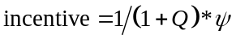,
where 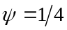 in this simulation to represent the plain assumption that 25% of the variation in observed encounter rates can be due to behavior. Here the
incentive multiplier = 1 – incentive.

and the cumulative incentive multiplier (CIM) is simply
CIM(t+1) = CIM(t) * incentive multiplier
and the incentive adjusted bycatch is

Market incentive adjusted bycatch = CIM(t) * actual bycatch at time t.

These dynamics are then incorporated into the simulation, and run forward to produce the results shown in Figure 9 and Figure 10. The results are similar but more dramatic than the earlier simple allocation and trading results (Figure 5) without rational incentives to improve relative standing in the fleet with respect to ITEC allocation.

It is important to note that even though the model was roughly scaled to fit observed variation, the results are highly dependent on the basic model assumption of self-correction and should be treated only as a plausible scenario to guide expectations. Actual implementation of the plan should allow one to retrospectively construct a more accurate incentive model, and the flexibility of model parameters should allow adjustments to suit desired performance criteria.

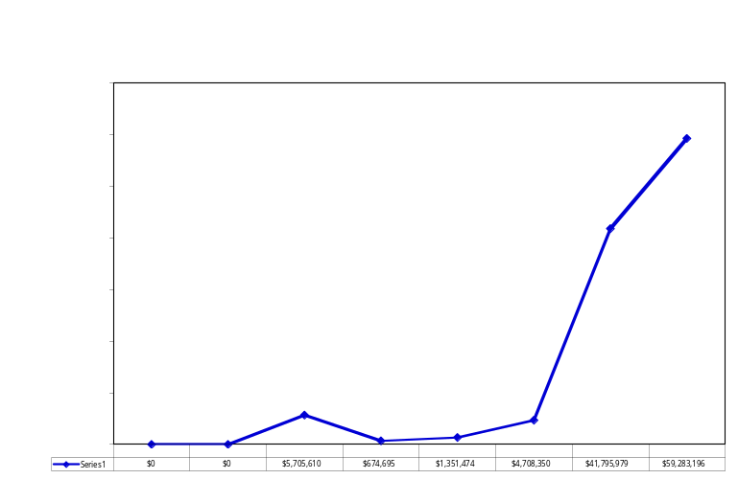
Figure 9. Hypothetical revenue gain (i.e., avoided revenue losses due to unharvested pollock resulting from hitting a hard cap) for the Inshore sector from trading and allocation incentives to avoid bycatch assuming a sector maximum hard cap of 36,900.

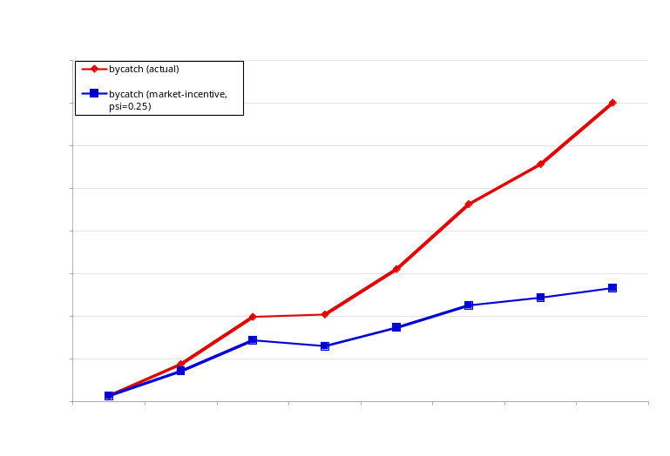
Figure 10. Effects for the Inshore sector of cumulative market incentives for reducing Chinook salmon bycatch under the PPA hard cap.

GLOSSARY OF TERMS:

1) Intrinsic Fishery Value = [(sum value of sector Pollock remaining at time t to the end of the season) / (sum sector actual bycatch remaining to the end of the season)] x [fraction of vessels in sector still fishing]
Note: this last term averages in the 0’s for the value when a vessel fills it’s quota. Thereby giving a weighted average to reflect the differences among vessel allocations and quota.

2) Instantaneous Expected Fishery Value = ( value of Pollock remaining at time t) / (cumulative bycatch rate at t)

3) Bycatch rate = #Chinook/mt Pollock

4) Back-of-the-envelope Upper Limit Bycatch Rate: 38,000/ 600,000mt = 0.063 = bycatch rate suggested by 38k HC and TAC of 600,000 mt for the inshore sector.

Literature Cited

AFA (American Fisheries Act). 1998. American Fisheries Act of 1998, Public Law 105-277. In: 16 USC 1801 et seq.
Anderson, L.G., 2002. Microeconomic Analysis of the Formation and Potential Reorganization of AFA Coops, Marine Resource Economics 17: 207–224.
Criddle, K. R. 2008. The legal context of US fisheries management and the evolution of rights-based management in Alaska. Pages 369-382 in R Townsend, R Shotton, & H Uchida (editors). Case Studies in Fisheries Self-Governance. FAO Fisheries Technical Paper. No. 504. Rome, FAO.
Criddle, K. R., and S. Macinko. 2000. A requiem for the IFQ in US fisheries? Marine Policy 24: 461-469.
Felthoven, R. 2002. Effects of the American Fisheries Act on capacity, utilization, and technical efficiency. Marine Resource Economics 17:181-205.
Ginter, J.J.C. 1995. The Alaska community development quota fisheries management program. Ocean & Coastal Management. 28(1-3): 147-163.
Hiatt, T., R. Felthoven, M. Dalton, B. Garber-Yonts, A. Haynie, D. Lew, J. Sepez, C. Seung, and Northern Economics, Inc. 2008. Stock Assessment and Fishery Evaluation Report for the Groundfish Fisheries of the Gulf of Alaska and Bering Sea/Aleutian Islands Area: Economic Status of the Groundfish Fisheries off Alaska, 2007. NOAA Fisheries Alaska Fishery Science Center, Seattle, WA.
Ianelli, J. N., S. Barbeaux, T. Honkalehto, S. Kotwicki, K. Aydin and N. Williamson. 2008. Eastern Bering Sea walleye pollock. In: Stock assessment and fishery evaluation report for the groundfish resources of the Bering Sea/Aleutian Islands regions. NPFMC, Anchorage, AK, section 1:37-98.
Magnuson Fishery Conservation and Management Act of 1976 (MSFCMA), 2006, Public Law 94-265 as amended by the Magnuson-Stevens Fishery Conservation and Management Reauthorization Act, Public Law 109-479. In: 16 USC 1801 et seq.
Myers, K.W., and D.E. Rogers. 1988. Stock origins of Chinook salmon in incidental catches by groundfish fisheries in the eastern Bering Sea. North American Journal of Fisheries Management 8:162-171.
Myers, K.W., R.V. Walker, J.L. Armstrong, and N.D. Davis. 2003. Estimates of the bycatch of Yukon River Chinook salmon in U.S. groundfish fisheries in the eastern Bering Sea, 1997-1999. Final Report to the Yukon River Drainage Fisheries Association, Contr. No. 04-001. SAFS-UW-0312, School of Aquatic and Fishery Sciences, University of Washington, Seattle. 59 p.
NMFS (National Marine Fisheries Service). 1995 Environmental Assessment/Regulatory Impact Review/Final Regulatory Flexibility Analysis for Proposed Alternatives to Limit Chinook Salmon Bycatch in the Bering Sea Trawl Fisheries: Amendment 21b to the Fishery Management Plan for the Ground Fish Fishery of the Bering Sea and Aleutian Islands Area. NPFMC, Anchorage, AK,
NMFS (National Marine Fisheries Service). 1996. Environmental Assessment and Regulatory Impact Review for Amendment 26 to the Fishery Management Plan for Groundfish of the Bering Sea and Aleutian Island Area and Amendment 29 to the Fishery Management Plan for Groundfish of the Gulf of Alaska; NMFS Authorized Distribution of Salmon Bycatch in the Groundfish Fisheries Off Alaska to Economically Disadvantaged Individuals. NMFS, Juneau, AK. 32 p.
NMFS (National Marine Fisheries Service). 1999. Environmental Assessment/Regulatory Impact Review/Initial Regulatory Flexibility Analysis for an Amendment to Further Reduce Chinook Salmon Bycatch in Groundfish Trawl Fisheries of the Bering Sea and Aleutian Islands Area: Amendment 58 to the Fishery Management Plan for Bering Sea and Aleutian Islands Area. NMFS Alaska Regional Office, Juneau, AK.
NMFS (National Marine Fisheries Service). 2002. Final Environmental Impact Statement for the American Fisheries Act. NMFS Alaska Regional Office, Juneau, AK.
NPFMC (North Pacific Fishery Management Council). North Pacific Fishery Management Council (NPFMC), 1990, Fishery Management Plan for the Salmon Fisheries in the EEZ off the Coast of Alaska, Anchorage, AK 210 pp.
NPFMC (North Pacific Fishery Management Council). 2002. Impacts of the American Fisheries Act. NPFMC, Anchorage, AK.
NPFMC (North Pacific Fishery Management Council). 2005. Environmental Assessment/Regulatory Impact Review/Initial Regulatory Flexibility Assessment for modifying existing measures for Chinook and chum salmon savings areas for Amendment 84 to the BSAI Groundfish FMP. NPFMC, Anchorage, AK,
NPFMC (North Pacific Fishery Management Council). 2008. Bering Sea Chinook Salmon Bycatch Management Draft Environmental Impact Statement/Regulatory Impact Review/Initial Regulatory Flexibility Analysis, Amendment 91 to the Fishery Management Plan for Groundfish of the Bering Sea and Aleutian Islands Management Area. NPFMC, Anchorage, AK.
NPFMC (North Pacific Fishery Management Council).North Pacific Fishery Management Council (NPFMC), 2009, Fishery Management Plan for Groundfish of the Bering Sea and Aleutian Islands Management Area, Anchorage, AK. 140 pp.
NRC (National Research Council). 1999. The Community Development Quota Program in Alaska. National Academy Press, Washington, D.C.
Pacific Salmon Treaty, 1985, Treaty between the United States of America and the Government of Canada Concerning Pacific Salmon, 23 pp.
Rico, 1995. The U.S. allowance trading system for sulfur dioxide: An update on market experience. Environmental and Resource Economics 5(2):
SeaShare. 2008. Application for Permit renewal to operate as NMFS Authorized Distributor of Salmon. SeaShare, 600 Ericksen Avenue, Suite 310, Bainbridge Island, WA 98110. 21 p.
Wilen, J.E. and E.J. Richardson 2008. Rent generation in the Alaskan pollock conservation cooperative Pages 361-368 in R Townsend, R Shotton, & H Uchida (editors). Case Studies in Fisheries Self-Governance. FAO Fisheries Technical Paper. No. 504. Rome, FAO.
Wilmot, R.L., C.M. Kondzela, C.M. Guthrie, and M.S. Masuda. 1998. Genetic stock identification of chum salmon harvested incidentally in the 1994 and 1995 Bering Sea trawl fishery. N. Pac. Anadr. Fish Comm. Bull., 1:285–299.
Witherell, D.W., D. Ackley and C. Coon. 2002. An overview of salmon bycatch in Alaska groundfish fisheries. Alaska Fishery Research Bulletin (9)1:53-6.

Appendix A: Technical Issues Regarding the Allocation Formula

Here we examine several technical issues related to the allocation equation (1)
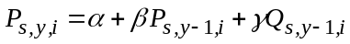

1) Scaling:
The proportional allocation formula (1) is transformed into number of credits as follows:
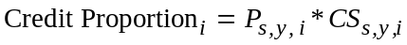
where CS is the AFA Cooperative catch share.
Because the sum of this product across vessels does not necessarily equal one, it is necessary to divide by the sum of these credit proportions over all active vessels in the sector:

2) Upper and lower bounds for proportional allocations:
When the weightings are such that 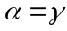 the lower and upper bounds on P will depend only on the bounds for Q. Thus, for both equations (2) and (3) the bounds for P are the same [] when the bounds for Q are [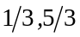] (obtained when 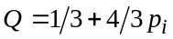). The following bounds for P apply to the following parameter settings for δ and ε in Q: (in order of wide to narrow limits):
[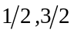] 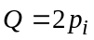
[]
[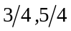] 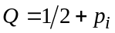
When weightings are , (equation 4), the upper and lower bounds are undefined, but can be set arbitrarily as absorbing boundaries to a random walk. They are independent of Q.

3) Specific forms for the penalty function p:
In general p can be any function defined on the interval 0 to 1 that rewards low bycatch behavior and that penalizes high bycatch behavior. The performance measure chosen here involves computing a z-score for bycatch rate and converting via linear scaling. Vessels with 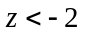 receive a 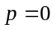, and vessels with 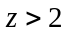 receive a 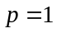. Vessels with 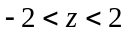 have 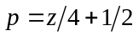. Note that this penalty function provides equal incentive for the vast majority of vessels. Here, the incentive is directly related to the slope of the penalty function: a greater slope indicates a greater change in credit reallocation for the same change in bycatch rate.
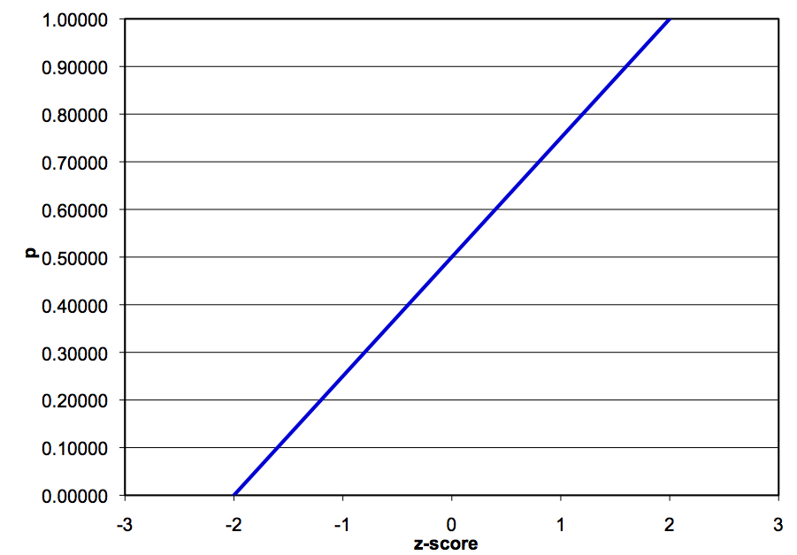
Figure A- . A linear penalty function truncated at z-scores of +2 and -2. Because the slope of the penalty function is equal for all z-scores, all vessels have equal incentive to reduce bycatch regardless of their position in the pack.

An alternative penalty function was considered that uses each vessel’s z-score to compute a cumulative p-value based on a normal distribution. This penalty function would create the highest incentives in any year to the most vessels. These are the vessels in the middle of the pack can move up and down in Q value more quickly than those at the extremes. It also protects vessels that are at the extremes (in particular the lower extreme of high encounter rates). This is a way to helping to buffer against bad luck. That is, with this form of Q incentive to improve is large for the most vessels, and “occasional” accidents are buffered. The main disadvantage is that it exposes the average player to more variation. More incentive and more variation are two sides of the same coin.

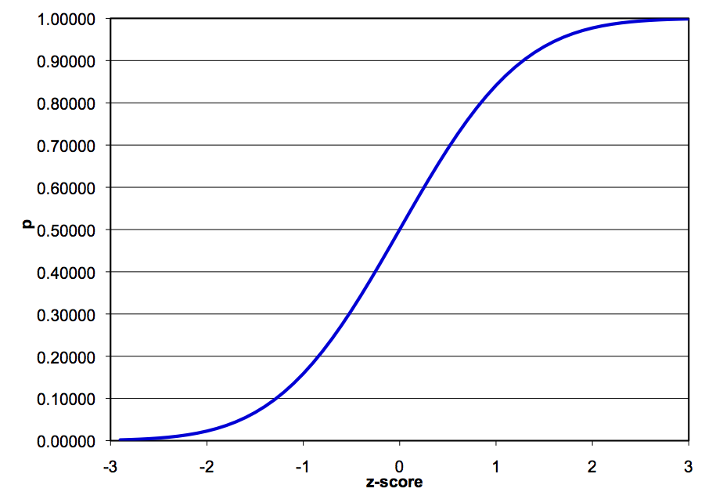
Figure A- . A penalty function computed as the cumulative p-value of the z-score. The slope is highest in the middle: therefore the largest incentives are for vessels in the middle of the pack.

Another possibility is to construct a function for Q that is flat in the middle so that average vessels will see very little change (the fleet will have less incentive) and so that the extreme bad luck year is more readily penalized. The advantage of this kind of function is that it will dampen the effects of random chance for the middle of the pack but at the cost of creating less incentive for the pack as a whole to improve. Overall, tinkering with Q makes more sense in systems that lack a legacy component to help buffer random events. Though modifying Q still might merit some additional experimentation, the main idea is to create incentives to shift the whole fleet over to have lower bycatch from year to year. That said, the real issue is not so much what the p-value is (how sensitive it is to changes in z-score) but how the “allocation” actually varies, and the legacy system gives some buffering capacity there.

4) Computation of z-scores:
The variance in bycatch rates between vessels can be attributed in part to chance encounters with patchy pockets of Chinook salmon (which is related in part to sample size effects or sampling variation and vessel size), and in part to consistent behaviors shown by vessels that appear to directly influence bycatch rates (caution in gear deployment, towing speed, choice of fishing location, timing etc).

One reasonable expectation of the MIP is for the distribution of bycatch rates among vessels to decrease over time as vessels exploit the same behavioral changes to reduce bycatch rates. A larger proportion of the variation in bycatch rates would then be due to random chance and not intentional behavior on the part of vessels. Since z-scores are scaled to the standard deviation of the bycatch rates, large fluctuations in z-scores may become due to random chance. To mitigate this problem, we use an estimated standard deviation based upon a sector-wide bycatch rate. (equivalent to a weighted average of individual vessel’s bycatch rates) This calculation is based on historical data across the Inshore Catcher-Vessel sector, the Mothership sector, and the Catcher-Processor sector. (Figure A- )

Because small vessels are subject to more sampling error (Figure A- ), we also use a corrected standard deviation to reduce the effects of random noise due to vessel size. This random noise varies with the inverse square root of 1 + pollock allocation %. Thus, we correct standard deviation in the following way:
This adjusted standard deviation is then used to calculate the z-score for vessel i:
Note that this calculation for z-score is of the opposite sign of the traditional calculation of z-scores. Thus, high bycatch rates (corresponding to poor performing vessels) map to negative z-scores and low bycatch rates (corresponding to the best performing vessels) map to positive z-scores.
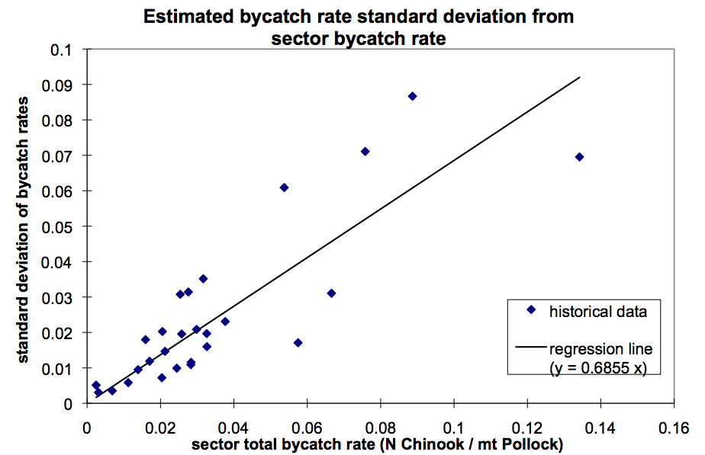
Figure A- . Standard deviation of bycatch rates as a function of sector total bycatch rate. (Annual data from multiple sectors. Provided by Sea State).

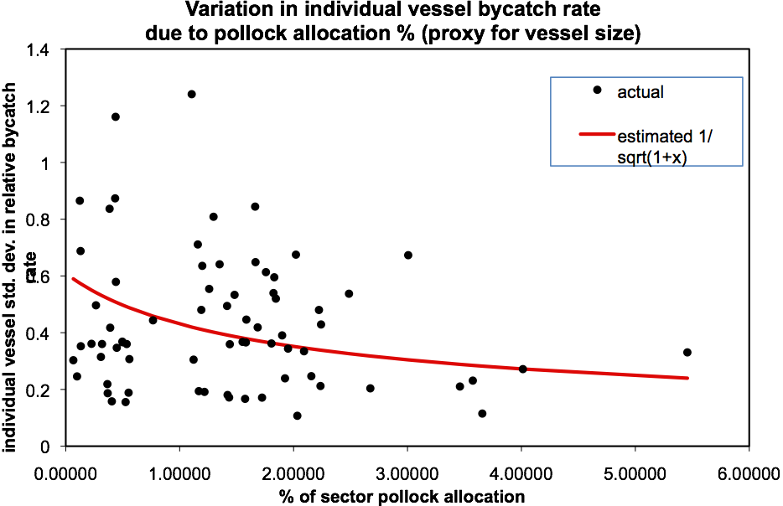
Figure A- . Smaller vessels show higher variability in bycatch rates. (annual data)

5) Convergence:
The legacy weighting not only affects the magnitude of the variance in credit allocations P, (a smaller γ results in lower year to year variation in P), but it also affects the rate at which one can move in the pack in terms of allocations due to directed behavior. The graphs below (Fig A-3a,b) show the extreme cases realized by the two different weighting schemes: () and (). There is little substantial difference between these schemes and

If one uses the weighting scheme () the legacy component receives less weight than (), and incentives are increased (larger change in allocations from year-to-year). However, fluctuations in allocation due to random noise affecting bycatch rates are similarly magnified and should be taken into account when choosing a weighting system

A degenerate form (equation 4) of the Legacy Allocation formula creates equal incentive for the same performance regardless of the previous season’s credit proportion. This form has changes in credit proportion computed solely based on the current season’s relative bycatch rate. In order to achieve the same asymptotic bounds of [], we set hard limits on the values of P, the credit proportion.

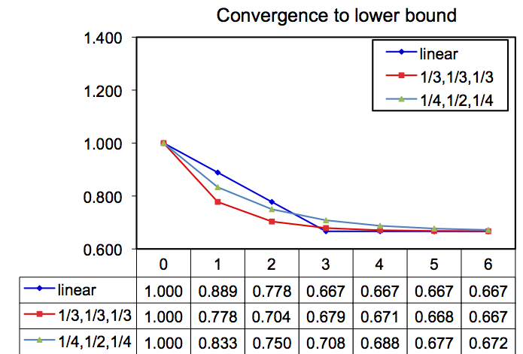

Figure A- . Comparison of two weightings of the legacy component. Assuming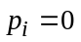, worst case. The more heavily weighted legacy component converges slower.

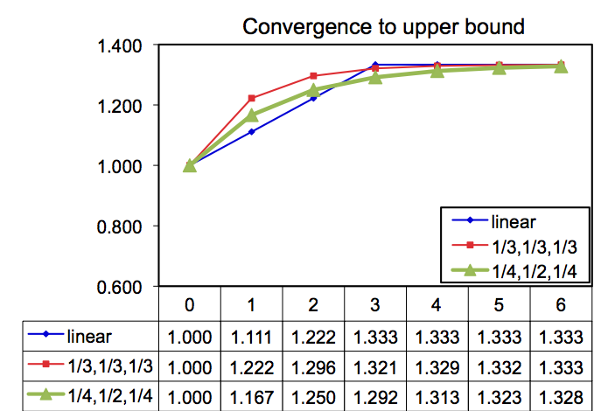
Figure A- . Comparison of two weightings of the legacy component. Assuming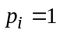, best case. The more heavily weighted legacy component converges slower.

6) Incentives in the False Legacy Model:
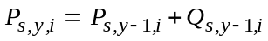 (4)

The “false legacy allocation” (equation 4) does not contain cumulative incentives to continue improving bycatch rates. To see this, simply notice that having a bycatch rate near the middle of the pack results in no change in proportional allocation (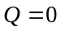). This property poses a problem for vessels that initially do well (have low encounter rates; improving proportional allocation) and then “slack off”: as long as these vessels do not have bycatch rates higher than average, their proportional allocation factor will not decrease.

In addition, because of the fixed upper bound (4/3) on the proportional allocation factor, vessels that are at that upper bound have no incentive to have the lowest bycatch rates. As mentioned earlier, these vessels will not experience a decrease in proportional allocation as long as their bycatch rates are better (i.e., lower) than average.

Perhaps the more problematic issue is those vessels who are at the fixed lower bound (2/3) for the proportional allocation factor. These vessels may actually improve their bycatch rates from what they were before, but will see no change in proportional allocation factor unless they can bring these bycatch rates to be better (i.e., lower) than average. Thus, their incentive to change fishing behavior may be significantly reduced, as only a major change in bycatch rate can alter their position.
Appendix B: Technical Issues Regarding the Fixed Transfer Tax and Dynamic Salmon Savings

1) Fixed Transfer Tax:
With a Fixed Transfer Tax (FTT), a fixed percentage of credits are retired for every ITEC transaction. For our simulation, we used a FTT rate of 20%: if a vessel wished to buy 100 credits, 20% or 20 credits would be retired as the “transfer tax”, so that a total of 120 credits would be removed from a seller’s pool of ITEC, but only 100 would be transferred to the buyer.

2) Dynamic Salmon Savings:
Under a Dynamic Salmon Savings rule, a percentage of a vessel’s remaining credits are retired when that vessel finishes fishing its Pollock quota: this percentage is the Salmon Savings Rate (SSR). To prevent vessels from selling credits before finishing fishing and avoiding having credits retired, it is additionally required that vessels who sell credits before finishing fishing reserve the appropriate fraction of credits corresponding to the SSR (or the maximum upper bound on SSR if the SSR has not yet been determined). In our simulation, we used 40% as the maximum upper bound on SSR.

(i) Provisional Salmon Savings Rule:
Note that prior to the completion of fishing and having credits retired based on the SSR, vessels may still transfer credits provided that an appropriate number of credits are set aside to cover eventual retirement.

For example, if a cap is set so the largest Salmon Savings Rate is 40% (a number that historically will not limit the harvest), then prior to setting the SSR, boats that have finished fishing early can only sell up to 60% of their remainder credits. This means that if a vessel has wishes to sell 60 credits early in the season, it must keep 40 ITEC in reserve until the SSR has been determined.

Alternatively, if the SSR has been determined to be, say, 20%, vessels that wish to sell credits before fishing the entirety of their Pollock allocation must retire an additional 25% credits for each transaction. For example, if that vessel sold 80 credits, it would retire an additional 25% or 20 credits. This fraction is equivalent to applying the SSR of 20% on a vessel that finishes fishing Pollock with 100 credits remaining: for this hypothetical vessel, 20 credits would be retired, leaving it with 80 credits to sell, exactly the same as in the example.

(ii) Calculating a savings rate:
Numerical experiments with the Inshore daily data suggest that calculating the savings fraction when 2/3 of the sector Pollock quota are caught (2/3 sector TAC) gives the best result, in terms of estimating the credits needed to complete the season. This is the “estimated total sector by-catch for the B-season.” This estimate normally occurs between August 29 and Sept 16 (see figure and table below). This tends to happen later in low salmon abundance years (when fewer transfers are needed) and occurs earlier in moderate to high abundance years.

The “estimated number of surplus credits” in the table below is the (current number of credits for the sector on the date that the salmon savings rate is calculated) - (estimated total B-season bycatch for the sector + buffer). Here the buffer is 5000, to account for error in the estimates of total sector by-catch.

The final “allowable salmon savings rate” would then be (the number of estimated surplus credits) / (current number of credits for the fleet). It is called an” allowable salmon savings rate” in that under this SSR, the Pollock harvest for the sector would not be limited by the availability of salmon encounter credits. These numbers are shown in the blue region of the table below. Notice that in high abundance years the SSR is 0%. and in low salmon abundance years the allowable SSR can be as high as ~79.6%. That is, in year 2000, we would be confident of fishing the entire Pollock quota (with margin for error) if the SSR were set at 79.6%. However such a high rate would put a damper on trading before the rate was posted (albeit, in 2000 no transfers were ultimately necessary). Alternatively, we can set a cap on this rate (say 40%), so that early trading can occur more readily if needed. Then any year where the estimated SSR is above 40% would automatically set the SSR at 40%. Agreeing to retire up to 40% would be thought of favorably by the Chinook salmon interests.
 | Dynamic Salmon Savings Rate (at end of B season) |  |  |  |  |  | UNKNOWN
year | A | B | C | D | E | F | G
2000 | 16-Sep | 37001 | 254 | 7540 | 29461 | 79.6% | 711
2001 | 11-Sep | 31578 | 277 | 7770 | 23808 | 75.4% | 2743
2002 | 5-Sep | 24955 | 1655 | 21550 | 3405 | 13.6% | 9622
2003 | 2-Sep | 24318 | 256 | 7560 | 16758 | 68.9% | 7144
2004 | 31-Aug | 25859 | 1890 | 23900 | 1959 | 7.6% | 20924
2005 | 29-Aug | 21122 | 4142 | 46420 | (25298) | 0.0% | 33734
2006 | 10-Sep | 12182 | 3591 | 40910 | (28728) | 0.0% | 21179
2007 | 2-Sep | 14848 | 1465 | 19650 | (4802) | 0.0% | 33813
A = date when 2/3 pollock caught
B = sector credits remaining (includes 100% carry-forward from A season)
C = bycatch caught (up to the date in A)
D = predicted total bycatch (for season) + buffer (computed as D = 10 C + 5000)
E = estimated surplus credits (computed as E = B – D)
F = allowable salmon savings rate (computed as F = E / B)
G = actual total bycatch (for season)
Table B - . calculation of SSR for the Inshore Catcher-Vessel sector for years 2000 - 2007

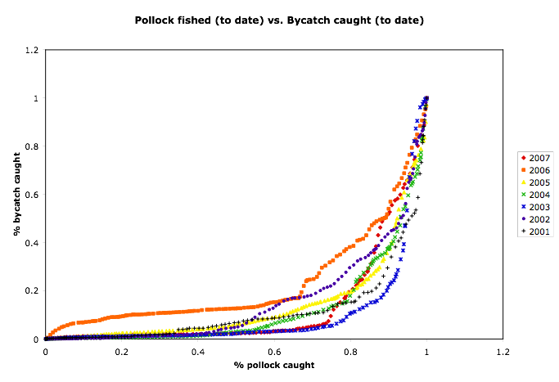
Figure B - . Cumulative bycatch as a function of % pollock harvested during the B season.

- Simulation results:
The yearly data for quantities of ITEC retired as a function of yearly bycatch (a proxy for salmon abundance) under both the FTT and DSS schemes are shown in Figure B - and Table B - . Not only is the total quantity of credits retired through DSS higher for this eight year period (2000 – 2007), but the number of ITEC retired is high in years of low salmon abundance: precisely when the potential for abusing extra ITEC is the highest! Conversely, the quantity of credits retired through FTT is highest in mid-abundance years: when the most transactions take place (due to a balance of availability and demand). Increasing the FTT rate to recover more ITEC has the potential of reducing credit transfers in mid-abundance years. The subsequent revenue loss can be extreme if a high FTT rate is chosen.

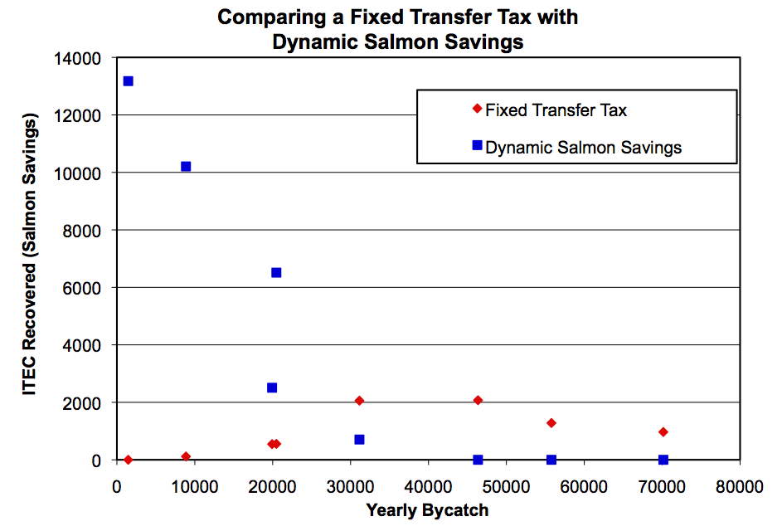
Figure B - . Number of ITEC recovered vs. yearly bycatch (proxy for Chinook salmon abundance) for two different sell-side transfer rules. More ITEC is saved during low Chinook salmon abundance years using Dynamic Salmon Savings.

 | RETIRED CREDITS
TOTAL BYCATCH | Fixed Transfer Tax | Dynamic Salmon Savings
1454 | 0 | 13177
8866 | 116 | 10208
19923 | 546 | 2507
20471 | 554 | 6513
31136 | 2058 | 706
46354 | 2073 | 0
55782 | 1281 | 0
70148 | 968 | 0
Table B - . Number of ITEC recovered vs. yearly bycatch (proxy for salmon abundance) for two different sell-side transfer rules.

APPENDIX C:

Temporal Analysis of Credits Supply and Intrinsic Fishery Value of Credits 2003 – 2007.
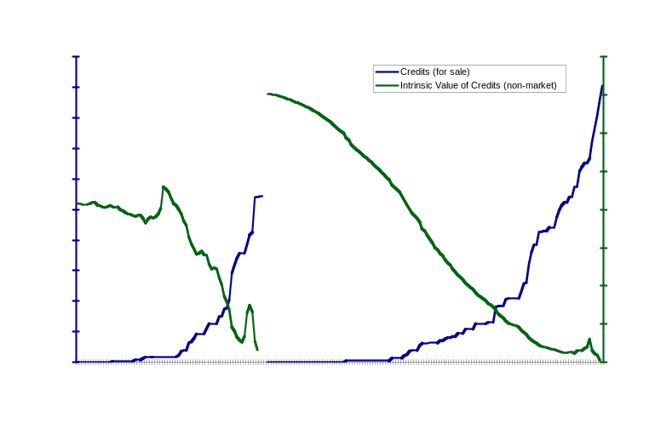

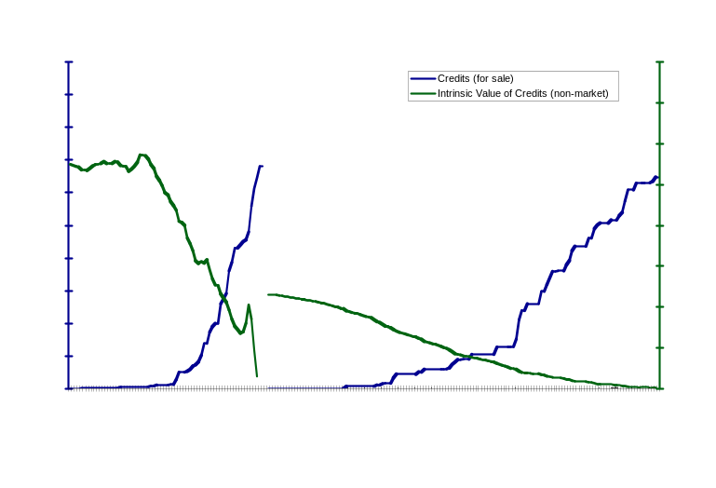

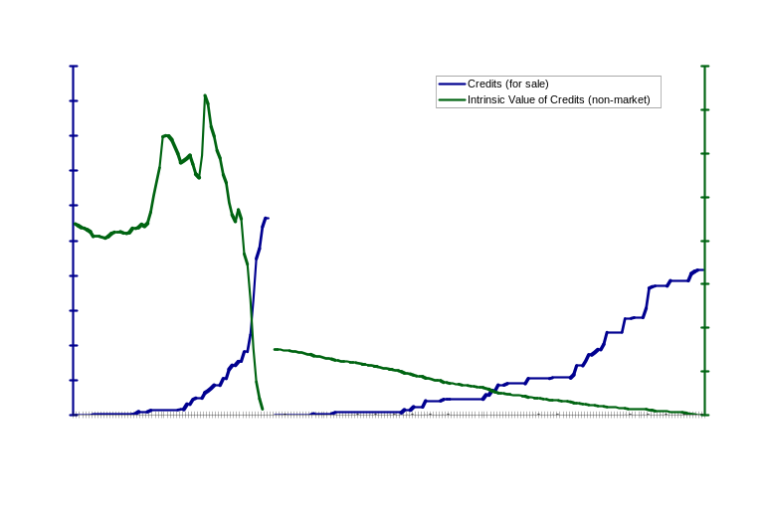

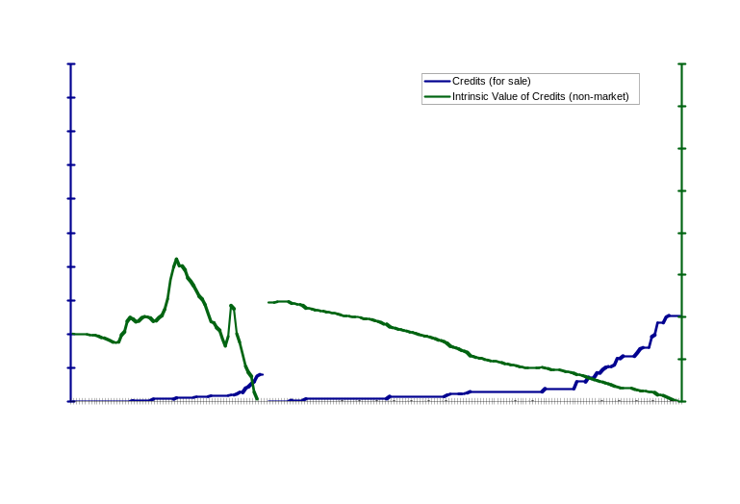

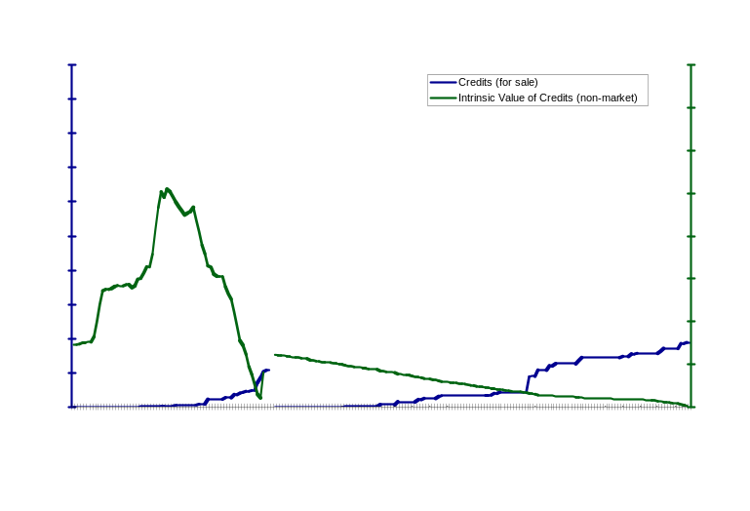
APPENDIX D: Afterthoughts for Consideration by Industry

- It may be desirable to allow coops to impose a small 3% (not exceeding 3%) tax on all vessel credits allocations to create an Emergency Fund for extreme bad luck cases. This small “emergency fund” could be used to help bail out any vessel that the coop determines had genuine bad luck. Any remainder credits could be put on the market by the coop toward the end of the year to raise revenue. The bad luck event (as deemed by a coop, or better yet a sector) could be incorporated into the legacy system (or not) by adjusting the bycatch rate to not fully reflect this event (say cut the number in half for that tow). This can only happen occasionally per vessel (e.g., once per vessel in 7 years).

- Handling Chronic Offenders with the “2-Strikes Rule:” (offered for consideration as an additional control for irrational players).

Chronic bad players who consistently have high bycatch rates relative to the rest of the fleet can place a drag on the overall performance of the fleet and harm its standing with regard to the Chinook salmon problem. They may be content with the minimal 2/3 allocation and be willing to wait until later in the season when credits could become more available as individual pollock quota are filled and/or vessels are more comfortable with selling surplus ITECat low prices. They may not care about the risk that next year may be a moderate to high abundance year, when ITEC will not be readily available, and may be willing to put their businesses at risk. Moreover as discussed, the credits may be uneconomic for the worst players, because they are worth less in terms of expected return on pollock.

One possible way to handle this is to implement a 2-Strikes Rule that suspends credits trading privileges from such repeat offenders in all seasons until they can demonstrate that they can move out of the worst category in any one season. It is ultimately up to the industry to decide the details of this rule and what defines this worst category (e.g., 3 standard deviations below the mean for 2 years running, or near the bottom of the list for 2 years running). Such a rule could quickly weed out the few worst players, and would likely only need to be in effect for some initial period. It has not been implemented in the current study.

To summarize, being a chronic offender is risky and uneconomic for several reasons:

- They will tend to run out of credits quickly because of their lower allocation.
- They will need to buy credits at a price that may not be economic given their high bycatch rates.
- They risk losing trading privileges.

The detrimental impacts of bycatch are largest when Chinook are rare: a fixed hard cap or fixed performance standard creates incentives to reduce bycatch independent of abundance. Incentives in these plans are unresponsive to underlying abundance.
The bycatch rate is the number of Chinook salmon caught per metric ton of pollock.
Dynamic Salmon Savings retires a variable fraction of the excess ITEC remaining after each vessel has completed its pollock harvest, diminishing the supply of tradable credits in low to moderate encounter times.
Dynamic Salmon Savings retires a variable fraction of the excess ITEC remaining after each vessel has completed its pollock harvest, diminishing the supply of tradable credits in low to moderate encounter times.
Chinook encounter rate = bycatch rate = [#Chinook caught] / [1 metric ton of Pollock]
Note: for analyses based on the annual data, allocations with P are based on annual averaged bycatch rates.
Note that the proportional allocation factor (P) is multiplied by the original ITEC allocation for each individual vessel to determine the number of credits that a vessel receives. In the first year of the program, ITEC allocations are pro rata to pollock allocations and . In subsequent years, P increases or decreases depending on bycatch performance, but will remain within the 2/3 and 4/3 bounds if the parameters are as described in Appendix A2.
Note: that when the upper and lower bounds on P do not change with different weightings. The bounds [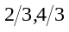] are the lower and upper bounds recommended here, but these can be adjusted if it is determined by monitoring outcomes that wider/narrower bounds would be more effective.
By sampling variation, we mean the variation in bycatch rates in a hypothetical experiment where two vessels are fishing in the same region at the same time in the same way. These vessels would be expected to have the same bycatch rate. However, a larger vessel is more likely to have a smaller variation in bycatch rate for multiple hauls than a smaller vessel. We do NOT refer to observer coverage of boats: we expect any plan with a hard cap on Chinook salmon bycatch will require 100% observer coverage for all vessels.

